The American Institute of Architects
Testimony Submitted to the Millennial Housing Commission

The American Institute of Architects

The American Institute of Architects (AIA), headquartered in Washington, D.C., is a national organization representing nearly 68,000 architects across the country. We are pleased to provide comments to the Millennial Housing Commission. AIA members represent a broad cross section of architects who work on all types of residences, from merchant to custom to affordable housing. We have a Housing Professional Interest Area (PIA) with nearly 2,700 members. Last year the Housing PIA’s Affordable Housing Task Force held a summit to discuss strategies for increasing the production and improving the quality of affordable housing. The AIA is committed to good design principles as a matter of professional practice. We have sponsored design award programs that recognize that good design is not only essential for advancing the state of our profession, but is instrumental to creating livable cities and nurturing communities. We present these examples at the end of our statement as evidence of how persuasive good design can be to making affordable housing more accepted.

Background

Americans are the best-housed people in the world. However, an estimated 14 million Americans have critical housing needs. The AIA Affordable Housing Task Force’s adopted goal states that all American families have a right to expect access to safe, decent, and affordable housing. The gap between the need for affordable housing and the supply continues to increase. In 1997, there was a shortfall of approximately 2.5 million affordable rental units. There are 5.3 million households with “worst-case needs,” an all-time high, and 10 million people spend more than half their income on housing.

At the federal level, housing budgets are insufficient to create and maintain an adequate supply of affordable housing. The private sector and a host of nonprofits, foundations, public housing authorities and faith-based organizations struggle to fill the need. Communities lack adequate strategies to replace deteriorating lower-income housing. “Not in my backyard” is increasingly “not in my city,” limiting location options for housing development. The gap between the number of available housing units and families in need of them grows ever wider.

The Housing Act of 1949 was courageously passed in recognition of a national and pervasive housing crisis following the Second World War. In response, for the past 50 years we have created a series of isolated symptomatic remedies to address specific issues while allowing the continuing and growing housing crisis to persist. After more than 50 years of a continuing “crisis,” it’s time to recognize the lack of housing for every American family as a chronic condition. We must begin the systemic change that can transform the current pattern of symptomatic treatment into therapeutic solutions.

The goal of achieving adequate, high-quality, affordable housing for all of our residents is no less significant than achieving adequacy in the health-care system or the educational system. Affordable housing is crucial to achieving overall socioeconomic stability and justice in this country and to setting an example for the broader global community.

Production of Affordable Housing

The federal government needs to increase its current commitment of funds to deal with the challenges of producing and financing affordable housing. These challenges include: cost and financing; continuation and expansion of successful federal, state, and local housing programs; and elimination of barriers to production.

What makes “affordable housing” affordable is the relationship between the cost of production and the income of the end user, not the cost of production alone. Although architects attempt to lower the cost of production, this approach alone cannot produce enough new housing to meet the demand. There is a dramatic need for housing working families, for housing to support the rehabilitative efforts of people with life issues trying to rejoin the workforce, and for housing for seniors to live out their later years with security and dignity. The housing affordability gap is widening. Rather than belaboring incremental shifts in programs or resources, we need to examine the potential for systemic change to the policies and public commitments necessary to change this delivery system.

Cost and Financing
In an effort to reduce construction costs, architects and builders have tried using innovative materials, designs, and construction processes. Many of these, unfortunately, have not been successful. For example, using a cheaper grade of materials may reduce construction cost but require more frequent replacement or higher operating and maintenance costs. In some parts of the country, baseboard electric heat is the least expensive to install initially, but it imposes significantly higher operating costs than other alternatives. Other design innovations may include the unconventional use of new construction methods, materials, or layouts. Unless these innovations are broadly accepted in the society at large, they can become stigmatizing to the resident population. An affordable-housing developer ought not be forced by budget constraints to use substandard materials or processes or otherwise sacrifice good design principles. The short- and long-term impact of these decisions can result in higher operating expense or have a blighting effect on a neighborhood, thereby causing more opposition to increased affordable housing production.

Further complicating the goal of cost containment is a rigid regulatory framework. Legal requirements for the protection of the public’s health, safety, and welfare such as fire sprinklers, accessible design features, lead paint and asbestos abatement, and energy conservation measures could never, in good conscience, be eliminated as a way to reduce costs. The social agenda for producing affordable housing may also work within a regulatory framework that requires procurement of services through contracting, payment of certain wage rates or project labor agreements, or local hiring plans. Again, these protections add cost while simultaneously advancing other social and economic development goals.

As an example, the U.S. Department of Housing and Urban Development (HUD) recently issued regulations to implement the Lead-Based Paint Poisoning Prevention Act as amended and the Residential Lead-Based Paint Hazard Reduction Act of 1992. Remediation of lead is a critical health issue. However, these regulations can increase the cost of renovating an older building by 15 to 35 percent. With incentives to develop and use new technology to remediate lead at a lower cost, we could increase production of affordable housing by renovating more of the existing stock.

Nonprofit developers need an easily accessible development loan fund for land acquisition and redevelopment expenses in order to compete with for-profit developers for certain properties. Even where sympathetic land owners agree to sell their parcels to nonprofit developers, the nonprofit developers often lose out on worthwhile properties because they cannot fund a purchase quickly enough or do not have access to a fund that would allow option payments and predevelopment work necessary to secure permanent financing. An operating fund would create access to much-needed capital to advance the development of desirable lots.

Inadequate funding increases the pressure on the existing housing stock. The scarce supply of subsidized units is often further reduced as properties are converted to market-rate housing. Even as the minimum wage inches up, rents, construction, and land costs rise even faster. Working poor families and others are losing their ability to secure safe and sanitary housing.

The decision to promote largely incremental approaches to increasing the number of newly constructed units has focused on increasing tax credits, bond caps, Section 8 vouchers, etc. These efforts, though important, will not by themselves solve the lack of adequate affordable housing for all who need/qualify for it. Some of the proposals the AIA has made and supported have been partially implemented. For example, funds have been allocated for additional Section 8 vouchers, but not enough and not every year. HUD’s budget has seen a significant increase over time, but most of that increase has gone to the Section 8 “mark to market” program to preserve the affordability of existing housing stock.

Current Federal Housing Programs
By and large, the public housing developments that have recently been revitalized through the HOPE VI program have distinguished themselves by their high-quality design as well as their participatory design process. However, the net impact has been to decrease the number of units available. So, although the housing that is produced is wonderful, we are housing fewer families. Without direct action to create new developments, the demand for independent, service-enriched, and assisted-living elder housing will easily outstrip the available supply as the population ages and longevity increases. It is a significant and as yet unanswered challenge to house the baby boomer population, which represents the largest number of the oldest persons in the history of the country.

Community Development Block Grant (CDBG) funds invested in communities near HOPE VI developments could be used to rehabilitate existing stock or build infill housing, for example, or give much-needed economic incentives to small businesses by financing Main Street programs. These enterprises bring vitality to a neighborhood by increasing the amount of capital spent in a neighborhood’s small-scale stores and services. These businesses can employ local residents, providing a focus to building a sense of community and pride. Additionally, in-home businesses could be encouraged through the design of housing types that include appropriately sized ground-floor rooms with direct-at-grade access.

The devolution of housing programs has moved federal housing resources closer to communities and the residents who need the housing that only those resources can provide. CDBG in the 1980s and HOME in the 1990s have been immensely valuable in strengthening state and local community-based initiatives to produce housing for a wide range of individual and family needs. The creativity they have stimulated among community-based developers in supplementing low-income housing tax credits and other below market-rate funds to serve very low and special needs populations should be rewarded and their funding expanded.

HUD’s Section 202 and Section 811 and the U.S. Department of Agriculture Rural Development’s Section 515 programs provide invaluable assistance in serving the elderly, disabled, and rural communities, but they are too small to address the needs that exist.

Many projects have multiple funding sources with different requirements that create inefficiencies and delays. Ideally, of course, programs would be so well-funded that only one source would be necessary to complete a project, and all worthy projects would be funded. Failing that, however, a “one stop” application, not unlike the application forms that many universities and colleges have agreed to use, can facilitate the process for applicants. If all affordable financing sources agreed to use this one form, then application time could be reduced and coordination of conditions for financing could be streamlined.

State and Local Programs
Housing and community development programs across the country incorporate the unique character and capacity of a given locality. Demonstration programs in Boston, San Francisco, or Seattle may work because of some local context that is not necessarily applicable to another city. However, a national policy should emphasize certain core values. For example, programs should promote participatory practices that build the capacity of citizens to affect positively the livability, health, and safety of neighborhoods. Such programs may be developed through Web-based training, like the new, HUD-sponsored Affordable Housing Design Advisor. Surplus buildings or land held by federal, state, or local governments could be evaluated for development potential as affordable housing. Housing Authority properties that are vacant due to their deteriorated condition should be redeveloped using expanded turnkey or HOPE VI programs. Of course, good local schools, good public transportation, and access to retail stores greatly enhance the prospects for success.

Other Barriers to Adequate Affordable Housing
Zoning regulations in many localities can often impede construction of affordable housing. These local land-use controls can impose costs, uncertainty, and delays that are ultimately passed on to consumers. More ominously, NIMBYists can use zoning laws to prevent affordable housing developments—even mixed-income or mixed-use projects—from ever being built. The federal government may want to look at incentives in its housing programs that would encourage communities to make their zoning regulations more flexible in order to accommodate affordable housing. Some states, such as Connecticut and Massachusetts, have implemented laws that help affordable housing developments overcome barriers posed by restrictive zoning. Nationwide, there is clear evidence that housing affordability is critically influenced not only by the nature of local land use controls, but also by the relative time delay and uncertainty of gaining regulatory approvals.

Cross-Cutting Issues

The AIA recognizes that creating well-planned, affordable housing is one of the most effective steps that can be taken to help communities become more livable and environmentally sustainable.

High-quality design is key to creating mixed-income housing that is accepted in a neighborhood. Inclusive communities require cultural and social integration. Economic diversity eliminates the economic stratification and isolation of “housing projects.” Access to community transportation systems eliminates isolation and enhances connectedness. Community building enhances neighborhood safety through partnerships and shared priorities.

The AIA recognizes that creating livable communities will be the primary challenge of design professionals, housing advocates, and the real estate and finance industries in this century. The AIA established its Center for Livable Communities to focus attention on this issue and commit its resources to educate, lead, and support its members to help meet this challenge.

To meet this goal, the AIA, with other industry partners, must define public policy initiatives that support this shared housing agenda. Together we must educate the public and government leaders about the need for public policy changes. Specific financing program proposals must also be developed, extended, increased, and/or augmented as part of this effort. We must jointly resolve to help create more livable communities by working to eliminate social, cultural, physical, regulatory, and economic barriers as we encourage economic, social, and racial and ethnic diversity.

Any talk of a new process must include a discussion of expanding resources through strategic public and private partnerships and other vehicles. For-profit, nonprofit, and governmental agencies at the local, state, and federal levels must be encouraged to work together to pool political, human, and economic resources. Realizing their potential for increased effectiveness will be vital to success. Community-based design and implementation strategies will become the centerpiece of a revitalized process. The key players in the process can achieve shared goals and expectations through community input.

Yet formation of partnerships to better serve those in need has been random at best; sporadic at worst. The result of this lack of cooperation is that high-quality, affordable housing has not been either produced or maintained at a rate that has kept pace with U.S. population growth. Moreover, affordable housing production has not kept pace with the increasingly complex social structure and the rate of socioeconomic problems.

Smart Growth policies and sustainable design are cornerstone efforts that should be brought to bear in conversations with the energy and construction industry. The federal government should sponsor workshops with large institutions like colleges, universities, hospitals, labor unions, and investment funds to look at their growth potential with and without aggressive development of more affordable housing. The AIA believes that the production of well-designed, well-constructed, and affordable housing is not a luxury but a necessity to the continued economic vitality of the country.

The myriad of individuals, groups, and organizations (public and private, nonprofit and for-profit) toiling independently of one another and/or in accidental or deliberate conflict with one another to deliver and maintain an adequate supply of satisfactory housing can benefit greatly from much closer cooperation. All players must begin to work together, share information, pool resources, and combine activities to improve the delivery, quantity, and quality of the nation’s housing.

Examples of Excellent Affordable Housing Design

Contrary to the old image of affordable housing projects as blights upon a neighborhood, high-quality, attractively designed affordable housing can improve the physical and social environment of a community. Good design will stimulate investment and encourage the mixed-use, mixed-income developments that help to build a more livable community. AIA member architects are at the forefront of helping to improve the design of affordable housing.

Design Advisor
The AIA has collaborated with HUD and several other partners to create the Affordable Housing Design Advisor, a Web-based tool to help architects, developers, sponsors, and users of affordable housing to understand what quality design is, why it is important, and how to achieve it. The Design Advisor, available at www.designadvisor.org, offers a gallery of exemplary affordable housing projects, a checklist of key design issues, “20 Steps to Design Quality” to make sure excellent design is incorporated into every phase of the development process, and a Project Book that helps guide decision-making over the entire course of an affordable housing project. With increased resources supporting and promoting a tool such as the Design Advisor, high-quality design could become easily accessible to anyone involved in designing or building affordable housing, and public design literacy could be enhanced.

AIA/HUD Secretary’s Housing and Community Design Awards
For the past two years, the AIA has cosponsored with HUD an awards program to recognize excellent projects in the categories of mixed-use/mixed-income development, community building by design, and housing accessibility. Attached are descriptions of the projects that have won these awards. These are the types of projects that federal policies should be encouraging.

Conclusion

Architects are skilled as process sculptors, designers, and facilitators. We all recognize the importance of working together—no longer fighting over a shrinking funding pie, but fighting with arms linked for broader support for an improved housing-delivery system that produces decent homes and a suitable living environment for all. The ultimate goal of increased housing production is to build livable communities that enrich and support the lives of the people of this nation.

Thank you for the opportunity to comment.
AIA/HUD Secretary’s Housing and Community Design Awards

The AIA’s Center for Livable Communities and the AIA Housing Professional Interest Area, in partnership with the U.S. Department of Housing and Urban Development (HUD), created this awards program to recognize the best in residential design. Categories include Mixed-Use/Mixed Income Development, Community Building by Design, and the Alan J. Rothman Housing Accessibility Award. Following are the award winners for 2000 and 2001.

Mixed-Use/Mixed-Income Development

This award recognizes projects that embrace and demonstrate the revitalizing potential of mixed-use and mixed-income housing developments. “Mixed-use” refers to developments that combine residential with nonresidential uses. “Mixed-income” refers to residential developments designed and financed to include market-rate as well as below-market-rate (affordable) housing.

Swan’s Market Place
Oakland, California
Architect: Pyatok Associates
Associate Architect: Y. H. Lee
Owner: East Bay Asian Local Development Corp.

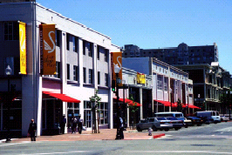
This project is an adaptive reuse of an historic downtown public market by a local nonprofit developer, incorporating into the existing shell a mix of residential units and 24 commercial and arts-related uses on a single city block. The development preserved a unique historic structure slated for demolition; built an economically viable project founded on small local businesses; converted a blighted block into a community gathering place and source of community pride; established a mix of artistic, cultural, and culinary traditions to serve a diverse downtown; attracted middle- and upper-income households to live and invest downtown; and provided new affordable housing integrated into the larger development.

Swan’s Market Place was created by and for the local community. In place of another homogenized new development, a group of local stakeholders invested enormous time and effort to create a complex, mixed-use development that recreates the intensity of small-commercial and residential uses characteristic of the city 80 years ago. This project exhibits excellence in design and adaptive reuse and addresses an urban streetscape in an especially interesting and successful manner. It is noteworthy for careful preservation of existing historic buildings and components and for helping to revitalize a depressed neighborhood for a diverse community.

Center Commons
Portland, Oregon
Architect: Vallaster and Corl Architects and Otak Architects PC
Developer: Lennar Affordable Housing

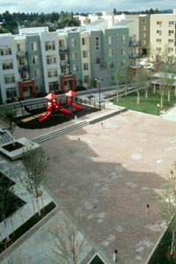
The challenge for architects involved in affordable housing is to maximize livability for tenants, design for neighborhood acceptability, and maintain budget. Center Commons meets and exceeds these goals. This transit-oriented development is adjacent to a light-rail station and bus routes. Limited on-site parking is mainly confined to areas behind and under buildings, freeing the center of the site for streets, a central plaza, and pedestrian-friendly walkways that connect the buildings. Street-level entry porches and decks define and give cadence to the street while providing a sense of security to pedestrians. A broad range of housing types supporting varied age groups, family structures, income levels, and physical abilities creates a new, vital, diverse community. Affordable senior housing overlooks a playground enclosed by the L-shaped affordable housing complex across from townhouses adjacent to market-rate apartments.

Community involvement was critical through all phases of the design process. In response to neighborhood and city input, a more diverse community evolved. In addition, retail space was added along the main commercial street, and the central community room, daycare area, and playground were opened to the entire community. This overtly modernist, mixed-income, transit-oriented, residential development features compelling design and excellent community process.

TriBeCa Pointe
Battery Park City, New York
Architect: Gruzen Samton LLP
Owner: Rockrose Development Corporation

This 42-story residential building demonstrates how the collaboration of a private developer, a public authority, and an architect can create a mixed-income neighborhood with diverse uses and a rich architectural character. The building brings mixed-income residential units, a retail store, a health club, a rooftop solarium, and a parks authority service space to the mixed-use community in which it is located. Eighty percent of the 340 rental apartments are rented at market rate and 20 percent at reduced rates to tenants whose income is less than half the median income of the city. The affordable units are distributed throughout the building and have similar orientation to the market-rate apartments.
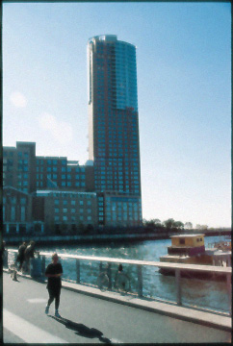
The design process was a true collaboration among a profit-oriented developer, a state authority charged with maintaining planning guidelines, and the architect. During the development of the design, variances were granted to the developer in exchange for community-wide benefits that were incorporated into the design. The design of the building maximizes the opportunities offered by the magnificent site and establishes relationships with neighboring structures. Its exemplary, compelling design exhibits an excellent contextual relationship with its neighborhood while making the most of its spectacular waterfront site. Although the project has only a 20 percent affordable unit component, in high-cost Manhattan, even small percentages of affordable housing mixed with market-rate housing should be encouraged. The project was deemed noteworthy for providing affordable housing without even remotely looking like affordable housing.

East Lake Commons
Decatur, Georgia
Architect: Village Habitat Design, LLC
Associate Architect: Pimsler Hoss Associates
Owner: East Lake Commons Homeowners Association

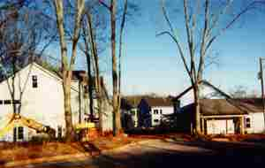
Located within three miles of the central business district, the project site was formerly a racially segregated area depressed by poorly managed public housing and red-lining by institutional lenders. The project’s goals were to create an environment that offered safe and easy human interactions to all its residents; broaden the range of community in terms of age, ability, activity, and income; and provide an intimate connection to nature and agriculture. The process began with educating the developer on how sustainable-living community design is more profitable than conventional development. The design process brought future residents together to begin to form a community before construction even began. Neighboring residents were also included in the site-design process. All of the buildings are clustered on 45 percent of the site, with parking at the adjacent commercial edge of the property. The homes are on a pedestrian series of avenues, lanes, plazas, and courtyards. Protected woodlands, wetlands, and a seven-acre vegetable farm are available to residents. This project is noteworthy for its unusual site design—clustering homes for density amidst Atlanta’s sprawl—and for incorporating the residual space gained thereby to create a working farm and open space on the more environmentally sensitive parts of the site.

First Ward Place

Charlotte, North Carolina

Architect: Urban Design Associates
Associate Architects: David Furman Architects and Fishero McGuire Krueger
Co-owner: Housing Authority of the City of Charlotte
Co-owner/ Developer: Banc of America Community Development Corporation

Once a crime-ridden area with 409 public housing units, this center-city ward has been remodeled and restructured into a mixed-income and mixed-environment community. First Ward Place now displays rental units for the elderly, median-income-level families, and market-level families, as well as a park and pedestrian areas with a mix of retail, business, and entertainment. Built through the combined efforts and funds of public and private investors, First Ward Place will include an office district and more mixed housing and apartment units. This project exemplifies some of the best results in HUD’s Hope VI program, offering evidence of high-quality design, a broad empowerment process, and a mix of uses and incomes, incorporating both rehabilitation and new construction.

Vermont Village Plaza

Los Angeles, California

Architect: Solomon E.T.C. Architecture and Urban Design
Developer: Vermont Village Plaza, LLC

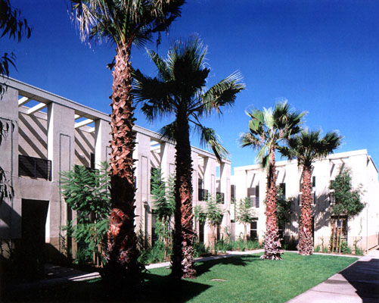
Built on the idea that “affordable home ownership is the key to neighborhood revitalization,” Vermont Village Plaza took a derelict residential community with a defunct commercial strip and transformed it into a mixed-use development. Vermont Village Plaza acts as an extension of an older residential area to its west and includes 36 houses with secured entry, private yards or large decks, and secure parking spaces. Incorporated among the residential buildings are units of community-based businesses with ample accessible parking on the frontage and limited parking lots. Vermont Village Plaza represents an innovative approach to affordable ownership housing, also incorporating secondary mixed uses. It achieves a unique aesthetic expression despite programmatic requirements for high density, substantial on-site parking, and a limited budget.

Community Building By Design

Community building is a people-based approach that uses the assets of the community to help neighborhoods as they rebuild social structures and relationships that may have been weakened by out-migration, disinvestment, and the isolation of inner-city areas. This award focuses attention on the participatory design process and on creating positive connections among residents, community stakeholders, local government officials, and civic groups. It also recognizes projects that play an exemplary role in revitalizing the communities in which they are located by enhancing the community’s physical fabric.

Arbolera De Vida
Albuquerque, New Mexico
Architect: Design Workshop
Architect: Studio E Architects
Owner: Sawmill Community Land Trust
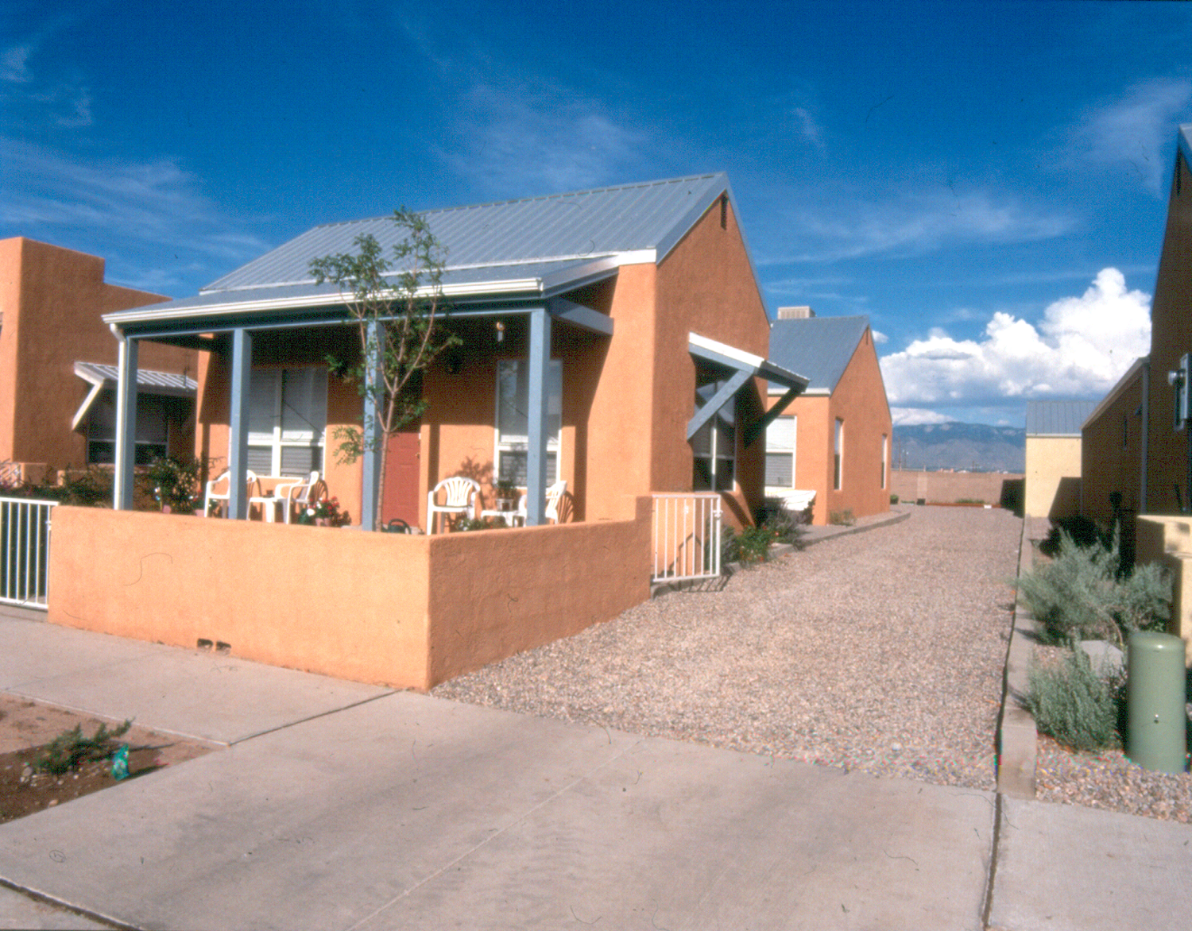
The design concept for this project was to extend and complete an existing neighborhood while giving it a cohesive and legible public realm. This was accomplished by replicating the existing block pattern eastward onto a former lumberyard and an abandoned railway right-of-way and organizing this extension around a spine of open spaces. To develop the initial plan, the design team and a local nonprofit land trust conducted a four-day workshop near the project site, intended to foster hands-on collaboration among the designers, citizens, and city staff. They also held two workshops with high-school and elementary-school children to solicit their needs, observations, and dreams. Adults had a standing invitation to drop by the daily work sessions and presentations.

The site includes single-family residences and introduces a mix of housing types, community services, and employment opportunities to the neighborhood. Further, the development is modeled on climatically responsive architecture and land-planning patterns. Buildings are oriented to maximize solar access, and shading is calibrated to block the summer sun while allowing the low winter sunlight to enter the house. Porches are set close to the street to foster interaction among neighbors. The project had excellent analytical drawings, community documentation, and physical plan. It is cohesive and makes its urban setting a far better place. Arrived at through a substantially inclusive process—it called the participants “citizen planners”—the remarkable design is contextually appropriate, unself-conscious, and historically correct.

Orchard Gardens
Roxbury, Massachussetts
Architect: Domenech Hicks & Krockmalnic, Inc.
Developers: Boston Housing Authority, Cruz Development Corporation, Madison Park Development Corporation, Orchard Gardens Resident Association, Trinity Financial

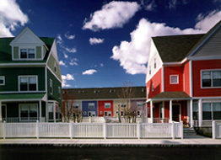
Highly participatory, this project harnessed the brain power of several different community members, including the developers, the Public Housing Authority Design and Development staff, the public housing residents, resident organizations from surrounding areas, and numerous city departments. Orchard Gardens was built in three phases after 585 severely distressed housing units were demolished. This project integrated mixed-income units into an urban fabric of commercial/retail and residential neighborhoods. Here is another example of design excellence achieved under HUD's Hope VI initiative. Noteworthy were the process of resident involvement and employment and the differentiation of building components through the strong use of color.

Portland Public Market

Portland, Maine

Architect: Hugh A. Boyd, Architects
Associate Architects: Orcutt Associates
Owner/ Developer: Libra Foundation—Market Ventures, Inc.

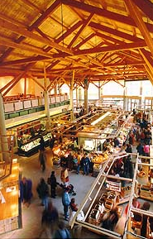Stemming from the good intentions of a philanthropist, this project was community-minded from its inception, educating the community in the purpose of the project. The Public Market houses booths for small farmers and food producers who sell locally produced goods and produce that reflect the cultural diversity of the region. This project has succeeded in revitalizing the downtown area; converting a dangerous, uninviting parking lot into a community center and drawing attention to and boosting the local economic development. In addition to its compelling site design and considerable architectural design/aesthetic appeal, Portland Public Market was judged to be an important example of best practices in community economic development. Especially noteworthy are the involvement and empowerment of small local vendors and low-income area residents, the purposeful building upon existing community assets in a transitional neighborhood, and the project’s obvious contribution to the quality of life for the entire community.

Alan J. Rothman Award for Housing Accessibility

Inglis Gardens at Eastwick
Philadelphia, Pennsylvania
Architect: Cecil Baker and Associates
Developer: Inglis Housing Corporation

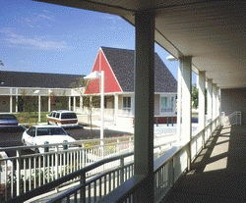
Located in the Eastwick Urban Renewal District near the Philadelphia airport, this site is in a community made up of apartments, townhouses, and strip malls. This development was meant for physically challenged individuals to live in a supportive environment with minimal daily assistance and yet be an integral part of the local community. Instead of the conventional three-story design anticipated by the owner, the architect proposed a single-story village for the same price. The village was in consonance with adjacent townhouse prototypes, created a secure and welcoming environment for its new residents, encouraged active use of outside areas, and set a framework to foster a sense of community. This project features a very thoughtful, well-measured architectural quality and uses economical materials to define a visually interesting and cohesive community space. The relatively conventional site plan/site design make good sense here, with green space in the middle of the site and easy visitor access to all dwellings. This entry represents an interesting approach to cost-effective development of a brownfields site.

Leland Apartments
San Francisco, California
Architect: Kwan Henmi Architecture/ Planning, Inc.
Developer: TODCO
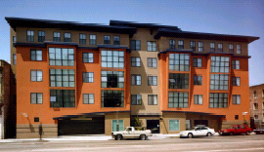
With the added challenge of dealing with input from various government agencies and community groups, the Leland Apartments project successfully surveyed and incorporated the advice of clients with disabilities. These apartments met the goal of building homes that provide an “affordable, fully accessible environment allowing the free movement of all tenants” as well as “an urban streetscape as good and stylish as any market-rate housing in the area.” Complementing the urban fabric of its surroundings, Leland Apartments was respectful to the architectural style and building uses of the neighborhoods in close proximity and to the wishes of the State Historic Preservation Office.

