Adapting Tax Technology to the Internet –
the eCommerce Transaction Tax Server

Submission to the Advisory Commission on Electronic Commerce
November 12, 1999

TAXWARE International, Inc
27 Congress Street
Salem, Massachusetts 01970
978-741-0101

Daniel L. Sullivan
CEO
dans@taxware.com
978-741-0101 ext. 103

Scott H. Walters
VP, Research & Development
scottw@taxware.com
978-741-0101 ext. 105

Jon W. Abolins
Director, Tax Department
jona@taxware.com
978-741-0101 ext. 151
I. INTRODUCTION

Over the past four years, the number of products and services sold through eCommerce has grown at an extraordinary rate. In 1996, TAXWARE International released the first software program that provided sales and use tax compliance for Internet merchants. The TAXWARE INTERNET Tax System was adapted to eCommerce despite the enactment of the Internet Tax Freedom Act, which did not preclude the application of existing transaction-based taxes to transactions occurring over the Internet. The INTERNET Tax System applied the technology of TAXWARE’s SALES/USE Tax System and its WORLDTAX System (International Tax Calculation). These programs, which have been developed over a period of twenty years, are being used by thousands of taxpayers. The INTERNET Tax System quickly became the system of choice for almost every eCommerce software system on the market today. The success of the program can be attributed to the speed and accuracy of tax calculations, as well as its affordability. Virtual merchants currently license the Internet Tax System for a little as $25.00 per year. The systems have significantly reduced the burden Internet merchants face in complying with state and local sales and use taxes.
INTERNET Tax System technology can further reduce the tax collection and reporting obligations of eCommerce merchants through the implementation of a Transaction Tax Server that would be operated in a service bureau environment. A Certified Sales Tax Service Provider (“CSTSP”) will be responsible for keeping up with tax rules and product definitions (exemptions) for all state and local taxing jurisdictions. This centralized tax collection service shall also be responsible for the reporting and payment of transaction taxes to the appropriate taxing authorities. The Service Provider, will absorb virtually all sales and use tax compliance burdens that plague merchants (retailers) today, creating a Zero Burden Tax Collection Scheme.

II. THE ZERO BURDEN TAX COLLECTION SYSTEM AND THE TRANSACTION TAX SERVER

While the Transaction Tax Server (“TTS”) concept does not require the implementation of the new Zero Burden Tax Collection System (the “Zero Burden System”) for application by any participating merchant, it does fulfill the requirements of the Zero Burden System. This software tool enables the widespread application of the Zero Burden System that has the ability to ease the tax compliance burden for all sellers required to administer sales and use tax. The technology needed to create a TTS exists today; and the execution of TTS to eCommerce merchants may occur over a period of time. This submission describes how TTS will work within the Zero Burden System, and addresses the criteria for evaluation identified by the Advisory Commission on Electronic Commerce.
It should be emphasized that TTS can be applied with or without the Zero Burden System, and can be implemented at a small cost to merchants (or at no cost to the merchant, if the tax authorities encourage participation by supporting TTS financially).

III TRANSACTION TAX SERVER

The Transaction Tax Server is a melding of various TAXWARE software systems (SALES/USE including Toolkit, WORLDTAX, VERAZIP and STEP) used during the tax calculation process. The address driven VERAZIP system validates the consumers address. Then, the seller (Merchant) and customer (Buyer) locations are compared to determine the taxing location, and the type of tax (i.e., sales or use). Exemptions are generated through the use of the Tax Rate File, the Product Taxability File and Merchant Exemption Files. Merchant Nexus Data Files allow sellers to implement their use tax collection obligation by turning off taxing jurisdictions in which they have no physical presence (point and click).
After transactions are calculated, the results are sent to the merchant’s billing system for entry onto the transaction document (i.e., invoice), and are stored in the Audit File. The ReMIT System places summary data from the Audit File onto the appropriate space on the tax return. This tax compliance system, ReMIT “Data Highway”, will be used to electronically transmit tax liability information. The same system used by tax payers to prepare and transmit tax returns shall be provided to taxing authorities that receive taxpayer returns. Thus, the taxpayer (pitcher) and the government (catcher) use the same system (ReMIT).
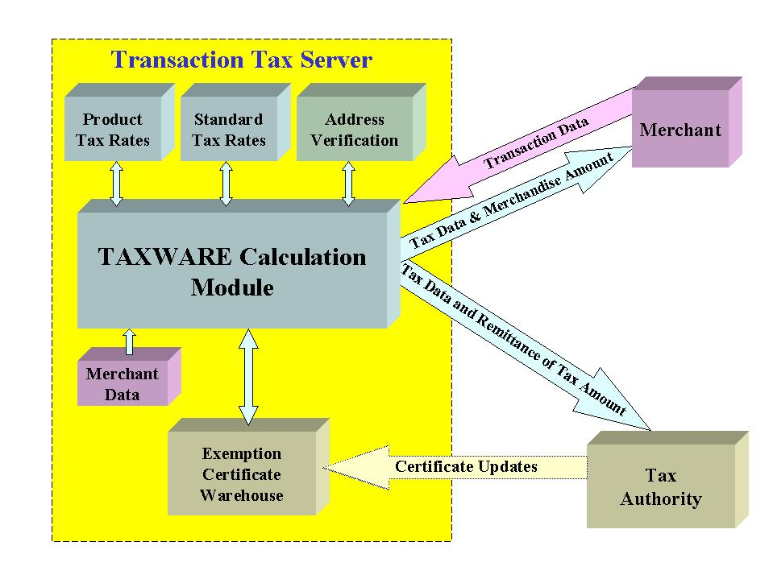
The process through which Internet sales are fulfilled consists of the following series of events:

- Buyers create orders to purchase products or services from virtual merchants.
- When buyers finish shopping, they will provide the address to which the purchase will be shipped as part of the checkout process.
- If buyers are purchasing digital products, the credit or debit card billing address will be applied as the taxing location.
- Sellers will transmit this information into TTS, which will calculate the appropriate tax on the transaction.
- The tax information will be reviewed by the buyers, who will either finalize or cancel the transaction.
- If the transaction is finalized, the buyer will be charged for the sales price plus appropriate tax.
- The seller, through the credit card or banking network, will receive the revenue generated from the transaction; appropriate tax authorities will receive the calculated tax amounts. Both the seller and the tax authority will also receive the tax information pertinent to the transaction.

Although the mission of the Advisory Commission is to recommend a tax scheme for eCommerce transactions, TTS can implement the concept into all areas of commerce. Technology used to tax Internet sales can be equally applied to sales occurring through catalog or mail order or through traditional storefronts. TTS technology can be applied to all types of taxes, including telecommunications, transportation, utilities, and any other kind of transactional taxes which must be collected and remitted.
Participation in the Zero Burden System is voluntary; any merchant with the technological capacity to tie in to TTS can participate. Because tax compliance will occur “real time” at the point of sale, participating merchants would be relieved of tax calculation, reporting and remittance obligations. Merchants will only be subject to “TTS Audits,” in which tax authority personnel review the configuration of merchants’ business practices into TTS. The CSTSP will fulfill all remaining audit responsibilities. Participating merchants would no longer need to monitor tax rate and law changes; in-house tax calculation systems would no longer be needed. Tax compliance and audit prevention and defense costs will be dramatically reduced.
Tax authorities will also benefit from the implementation of the Zero Burden System. Tax data can be received at the time of the sales transaction. Tax revenues can be transmitted to the tax authority almost immediately upon completion of the sale, increasing tax authorities’ time-value of money. Tax authority personnel can implement law changes immediately, and can monitor the application of rates and laws at any time. Tax authorities can also attach their existing back office systems to TTS by accommodating imports of tax data.
The CSTSP will be compensated through contracts with participating federal, state and local tax authorities. Payment can be based upon a reasonable percentage of tax calculated, the number of transactions processed by TTS, or a combination of both; funding will originate from the amount of tax collected, upon the value of float on tax collected, or a combination of both.

IV. CRITERIA FOR EVALUATION

Please note that this submission focuses upon the institution of the Zero Burden Tax System using the Transaction Tax Server. The responses to the criteria for evaluation describe the implementation of the Zero Burden System from the standpoint of a technology provider. Submissions regarding the Zero Burden System will address the policy issues behind each of the criteria; this submission merely describes how TTS will address the issues behind the criteria.

Simplification

1. The Transaction Tax Server Will Implement a Simplified Version of the Existing Sales Tax Collection System

TTS is a tool through which existing sales and use tax schemes can be automated. There is a clear need for the adoption of a coding system through which exemptions from tax bases can be identified. Each unique exemption must be identified with a unique code. “Commodity Codes” will identify exemptions that are based upon status of the commodity transferred or service performed, and “Reason Codes” will identify exemptions that are based upon the status of the purchaser or the use to which the purchase will be put. TAXWARE has developed a coding scheme that can be applied as the basis behind the adopted coding system. The coding schemes for Commodity and Reason Codes are amendable, allowing new exemptions to be added to the list.
The existence of thousands of local tax rates, in conjunction with hundreds of different tax bases, wreaks havoc upon the tax departments of multi-jurisdictional retailers. It is for this reason that today’s tax compliance software has become a necessity for any multi-jurisdictional vendor. This technology, when deployed into TTS, will eradicate the need to include resources to address this complexity in merchants’ budgets and project plans.
Because participation in the Zero Burden System is voluntary, no clarification of nexus standards is necessary for TTS implementation. Participating merchants will submit transactions to TTS in return for liberation from tax compliance obligations.

2. The Transaction Tax Server Automates Tax Compliance for eCommerce Transactions

TTS can implement any transaction tax system. After deployment, each taxing jurisdiction can decide how to tax information, digital goods and services provided electronically over the Internet.

3. The Transaction Tax Server Facilitates the Audit Process

Implementation of TTS will dramatically reduce the difficulty and expense inherent to transaction tax compliance. The Certified Sales Tax Service Provider will inherit the audit responsibility for all transactions calculated by TTS. Merchants will only be subject to TTS audits, to determine only whether their billing systems are correctly configured to TTS.
Tax authorities will benefit from the aggregation of all transaction tax data into one universal location, in one universal format. Such aggregation will reduce audit difficulty and expense from state and local governments. Data preparation and modification responsibilities will be dramatically curtailed. State and local auditors will work closely with the Certified Sales Tax Service Provider to audit all transactions calculated by TTS, and new, more accurate methods of sampling can be applied to audits of TTS performance. Further, state and local tax authorities will have the ability to monitor TTS on a monthly, daily, or even hourly basis. Finally, TTS technology allows for remote audits, reducing the need for travel to taxpayer locations to perform audits.

Taxation

4. The Transaction Tax Server Will Not Require the Imposition of Any Taxes on Internet Access or New Taxes on Internet Sales

The implementation of TTS is merely the tool used to implement legislative and regulatory tax decisions. If Internet access becomes taxable, or if Internet sales are subject to new taxes, TTS stands ready to implement the appropriate tax decisions. Conversely, if Internet access or other eCommerce transactions were granted exempt status, TTS can easily automate all aspects of that exemption. This flexibility makes TTS the ideal tool for automating the Zero Burden System.

5. The Transaction Tax Server Will Reduce Consumers’ Net Tax Burden

TTS will not increase consumers’ net tax burden; it will, in fact, facilitate the payment of consumers’ existing tax compliance obligation. Although most businesses comply with their obligation to remit use tax on untaxed purchases, most consumers are not aware that they have an existing duty to pay use tax on any non-taxed purchase they make. By automating the transaction tax compliance process, TTS removes the existing duty upon purchasers to calculate and report use tax on purchases from remote sellers. Furthermore, as overall use tax compliance increases, state coffers will increase concurrently. Ensuing budget surpluses could then justify reduced state and local tax rates, which would in turn reduce the tax compliance burden of the purchaser that purchases goods and services from in-state vendors.
The implementation of TTS would not reduce or increase taxes upon state and local telecommunication services or other charges on services designed or used for access to or use of the Internet. The versatility of TTS allows for easy implementation of reduced or increased taxes upon these products and services.

6. The Transaction Tax Server Will Not Inflict Tax Compliance Responsibilities on Sellers Without Physical Presence in the Taxing Jurisdiction in which their Customers Reside

Because the Zero Burden System will be a voluntary system, no vendor would be required to fulfill any additional tax compliance obligations. Accordingly, TTS would not be mandatory, but sellers that wish to participate will be required to configure their business practices into TTS. TTS allows merchants to designate the taxing jurisdictions in which they wish to participate in TTS.

7. The Transaction Tax Server Will Increase Governmental Revenue Bases

The automation of the Zero Burden System will indeed increase federal, state and local governmental revenue bases. The implementation of TTS will prevent taxpayers from shirking their use tax payment responsibilities, increasing tax remittances. Further, tax liabilities can be paid to the appropriate tax authorities as transactions occur, allowing governments to take advantage of the time-value of money.

Burdens on Sellers

8. The Transaction Tax Server Removes the Tax Compliance Burdens from Sellers

The Zero Burden System implemented through TTS will remove much of the current transaction tax compliance burden sellers face today. After sellers agree to participate in the Zero Burden System, they will open up a standard Internet browser, and surf to the CSTSP Merchant Sign Up Page. Through this page, merchants will set up their TTS account, input their business locations, and attach their catalog control numbers (“SKU’s”) to the appropriate Commodity Code. Merchants will also select the Zero Burden states that they agree to participate with. All functions use easy, point-and-click technology. The Sign Up Page appears as follows:

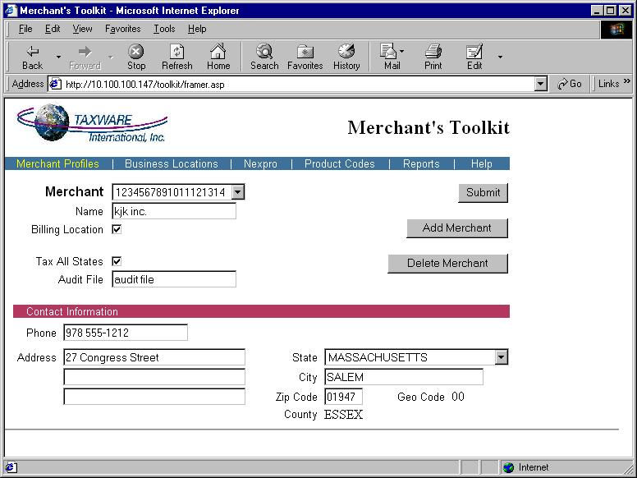

After initial configuration, sellers would only be subject to “TTS Audits,” through which tax authority personnel review the linkage between the merchants’ billing systems and TTS. Reviews will determine whether the merchant has accurately attached the appropriate data to TTS, and will also function as a fraud control mechanism.
The CSTSP would thereafter take on all tax compliance and audit responsibilities, removing the administrative burden from the merchant. Merchants participating in the Zero Burden System will have access to TTS for no cost; TTS will be funded through contractual relationships between the CSTSP and participating states. Further, some Zero Burden proposals provide for payment to merchants agreeing to participate at the onset of the program.
TTS does not include any special provisions with respect to small, medium-sized, or start-up businesses. Any business with a computer and internet access can utilize TTS for the same cost: $0.00.

Discrimination

9. The Transaction Tax Server Implements Uniformity in Tax Liabilities between eCommerce and Standard Transactions

Today’s transaction tax systems bestow a significant advantage upon remote sellers. Customers purchase goods from remote sellers because those customers believe such transactions are legitimately tax-free. Purchasers in general do not know of (or ignore) the use tax compliance obligation imposed upon their purchases from remote sellers. The remote vendor iniquity, publicized by the expansion of eCommerce, has existed for decades. TTS can easily be applied to all commerce, leveling the playing field for in-state vendors. eCommerce, mail order, catalog and in-store vendors can each access TTS. TTS would apply the same calculations across the same tax data for all participating merchants, regardless of the method the purchase order was created.

10. The Transaction Tax Server Implements Uniformity in Tax Liabilities for All Vendors
TTS will not automate discrimination against remote vendors. The voluntary nature of the Zero Burden System allows equal access to TTS by in-state and remote vendors alike. All types of vendors in all industries in which transaction tax liabilities are incurred can participate.

International

11. The Transaction Tax Server Increases Global Competitiveness for U.S. Businesses

Automating the Zero Burden System through implementation of TTS will increase the ability of U.S. businesses to participate in global commerce. Existing transaction tax schemes inflict a substantial burden on any merchant doing business in the United States. The removal of this burden will allow these merchants to reallocate resources currently used to comply with transaction tax obligations, increasing their ability to compete.

12. The Transaction Tax Server Achieves International Scalability

TTS can easily be scaled to the international level. Merchants from outside the United States will have access to TTS, allowing participation in the Zero Burden System. Furthermore, TAXWARE technology calculates and reports international transaction tax liabilities; such technology can rapidly be included in TTS. With the cooperation of international tax authorities, TTS would be the global transaction tax solution.

13. The Transaction Tax Server Implements Different eCommerce Tax Systems

TTS has the versatility to implement all existing transaction tax systems, including countries in which the origin of the transaction is deemed to be the tax situs. TTS fully automates transactions which are exempted (or zero rated) from transaction tax liability due to export. Although harmonization of global transaction tax schemes is desirable, TTS allows for the existence of many schemes.

Technology

14. The Transaction Tax Server: a Feasible Technological Solution Utilizing Widely Available Software

Businesses have been using widely available software to facilitate transaction tax compliance for more than twenty years. This well-proven software can be deployed into TTS, enabling all participants in the Zero Burden System to access tax compliance technology. Expenses incurred upon initial configuration of merchants’ business processes into TTS can be paid by participating state and local governments according to Zero Burden System.
Funding for CSTSP will be provided by participating state and local governments. Certified Sales Tax Service Provider will charge for their services based upon a reasonable percentage of tax calculated, the number of transactions processed by TTS, or a combination of both. TTS updates will be applied as needed; fees related to updates will be factored into the agreement between the CSTSP and the participating state or local government.

Privacy
15. The Transaction Tax Server Protects Purchasers’ Privacy

One of the most controversial components of eCommerce taxation is the need to protect purchasers’ privacy. This concern stems from the creation of detailed information that will be collected through automating the Zero Burden System. TTS can implement the Zero Burden System while preserving an eCommerce purchasers’ sensitive information.
Any citizen should rightly be concerned that information provided for tax compliance purpose be protected from unauthorized use. Any Certified Sales Tax Service Provider must therefore be required to maintain the privacy of tax data; inappropriate use would disqualify the CSTSP from further participation in the Zero Burden System.
It is important to note that no transaction tax can be accurately calculated unless the location at which the purchase will be used is known. TTS will derive this information from the mailing address the purchaser designates as the ship-to location (or the billing address for transactions of digital products). Fully taxable transactions require a review of purchasers’ mailing or billing addresses, but only the purchasers’ state, city and Zip Code will be stored in an Audit File. Purchasers’ names and street address information will not be retained.
If a transaction is fully or partially exempt, additional data must be retained. If the exemption is due to the status of the product or service purchased (i.e., food items), the Commodity Code assigned to the product or service by the vendor will be stored in the Audit File. If the transaction is exempt due the purchasers’ status as an exempt entity, or if the transaction is exempt because the purchase will be put to an exempt use, the applicable Reason Code will be retained to support the exemption. Such purchasers will be required to provide an Exemption Identification Number; existing exemption certificate numbers will be the basis of the identification number. TTS will store the Exemption Identification Number and the Reason Code in the Audit File, but the CSTSP will not be provided with the true identity of the holder of the number. Tax authorities will determine which exempt purchasers to audit based upon review of the transactions in which authorized Exemption Identification Numbers were used.

Sovereignty/Local Government Autonomy

16. The Transaction Tax Server Respects State and Native American Sovereignty

State governments unanimously wish to retain the ability to enact the tax base that is appropriate for their taxpayers. The perceived inability to simplify state transaction tax schemes while preserving state autonomy was instrumental in the failure of previous transaction tax simplification efforts. TTS automates all tax distinctions in all state tax bases, regardless of the complexity.
Native Americans wish to retain their exemption from transaction tax. TTS can automate this exemption through the use of the Exemption Identification Numbers that will be assigned to Native Americans. Exemptions for transactions occurring within Native American territory will also be available in TTS.

17. The Transaction Tax Server Respects Local Governmental Autonomy

Local governments also wish to retain the ability to enact the tax base that is appropriate for their taxpayers. The same methods used by TTS to automate varying state tax schemes are used to automate differing local tax schemes.

Constitutionality

18. The Implementation of the Transaction Tax Server is Constitutional

The voluntary nature of the Zero Burden System removes the constitutional barrier to imposing the use tax collection obligation on remote sellers.

V. CONCLUSION

In summary, TAXWARE recognizes the need for simplification of the existing sales and use tax system within the United States. We support the use of new tax technology that will shift the administrative burdens associated with transactional taxes away from the sellers of products and services. The Internet is creating many new business opportunities, and the tax dilemma eCommerce merchants face should not be the focal point of eCommerce discussions. Most governmental agencies and businesses would all agree that the tax system is too cumbersome and complex. The implementation of a Zero Burden System, which adopts the Transaction Tax Server technology, has the ability to simplify our sales and use tax system. A voluntary program adopting new technology to solve the eCommerce tax dilemma, that shifts the administrative compliance burden away from merchants, will only enhance the growth of the Internet and our free enterprise economy.

