Housing’s Impact on the Economy

Report of the
National Association of Home Builders

Submitted to the Millennial Housing Commission

November, 2001
Introduction

Housing has a pervasive impact on the U.S. economy and on the daily lives of its residents. Home building creates jobs for workers in their communities, sales for local and national businesses and product demand for manufacturers. Repairing and remodeling homes employs more workers and keeps the stock of homes up-to-date and useful. Moving and exchanging homes helps people locate where they work and where they want to live. Residing in homes gives families and individuals a place to call home, raise children and become a part of the community.

This paper describes the major housing impacts on the national economy, local business and workers and the community where homes are built and owned or rented by their residents. The paper is divided into three major sections: the macroeconomic impact of housing, the local economic impact and the impact on individuals and society.

The Macroeconomic Impacts of Housing

Gross Domestic Product (GDP), the measure of total production of goods and services in the nation, includes products for current consumption and the production of capital goods as an investment for future production. Housing is a major part of both current consumption and private investment. In 2000, the combination of consumption and investment spending on housing represented 14 percent of GDP. The share has varied little over the past 50 years as shown in Exhibit 1.

Investment

Construction of new homes is part of the investment component of GDP. Residential fixed investment (RFI) totaled $425 billion in 2000, representing 4.3 percent of GDP and 24.1 percent of gross private domestic investment (see Exhibit 2). New conventional single family and multifamily structures accounted for $249 billion, or 59 percent of RFI. The other major components of RFI include improvements to existing homes ($102 billion), real estate commissions ($55 billion), manufactured housing ($11 billion), and equipment such as appliances for rental housing ($9 billion). RFI is one of the more volatile components of GDP. Within the past 25 years, the RFI share of GDP has ranged from 3.2 percent in 1982 and 1991 to 5.7 percent in 1978. The most recent peak in that share was in 1999, when it was 4.4 percent.

In general, private investment consists of fixed investment in structures and equipment and of inventory investment. Construction is counted as fixed investment as the work occurs, not when the structure is completed or sold, so builders are not considered creating inventory, unless they accumulate materials for future use. The value of investment in new residential structures does not include the value of raw land, but it does include the value of land development.

Unlike the treatment of conventional homes and nonresidential structures, investment in manufactured housing is measured when the completed unit is shipped. It is noteworthy that new conventional single family and multifamily structures outweigh manufactured housing to a much great extent in terms of residential investment than in numbers of units. The average new conventional single family unit represents about four times as much investment as the average manufactured housing unit. The average multifamily unit represents about twice as much investment as the average manufactured housing unit.

Consumption

Output of the housing sector for consumption consists primarily of the services—the shelter and security—provided by the existing stock of housing. The payment of rent by tenants in rental housing is counted as part of consumer spending on services. In 2000, renters spent $209 billion for nonfarm housing services. That includes the services of appliances and furniture provided by property owners, but mainly just represents payments for use of the structure. The portion of rents paid in 2000 that is attributable to inclusion of appliances and furniture has been estimated as about $6 billion. In cases where utilities are also included in the rent paid by renters, the value of those utilities is excluded from the total rent and counted under consumer spending for energy.

The estimated rental value of owner-occupied homes is also counted as consumer spending on housing services. Homeowners are considered to be renting from themselves. In 2000, imputed rent for nonfarm owner-occupied housing was $710 billion. The treatment of owner-occupied housing, with homeowners considered to be business renting to themselves, is unique. The purchase by households of consumer durables such as cars, computers, and appliances is treated as current consumption, rather than investment. Arguably, households who buy cars or other durables could be said to be making investments and leasing use of those assets to themselves, but the data only treat residential structures in that way. In part, that is attributable to the fact that housing is more durable. Also, a shift toward home ownership would otherwise show up as a decline in GDP.

In total, personal consumption expenditures for housing services in 2000 were reported as $959 billion, representing 9.7 percent of GDP and 14.3 percent of total personal consumption expenditures (see Exhibit 2). The share of GDP has remained relatively constant over the last fifty years, from a high of 10.3% in 1991 to a low of 7.2% in 1951. Averages for each of the past five decades are more tightly bound around 13% to 15%.

In addition to the actual rent paid by tenants in nonfarm rental housing and the imputed rent for nonfarm owner-occupants, that includes actual or imputed rent for farm housing ($9 billion) and consumer spending for stays in hotels, dormitories and other group quarters ($39 billion). It may not really be appropriate to include spending on hotels in the housing category in the estimates personal consumption expenditures, especially since construction of hotels (but not dormitories) is classified as investment in nonresidential structures, and both transient and long-term group quarters are excluded. Excluding such spending would reduce the share of 2000 GDP attributable to consumption of housing services from 9.7 percent to 9.3 percent.

Except in cases where appliances or furnishings are included in the rents paid by renters, the value shown for personal consumption expenditures for housing does not include spending for household operations, such as utilities, as well as household purchases of appliances and furnishings. Such spending in 2000 came to $727 billion.

A change in residences also provides an extra stimulus to the economy. Households that move into a new or existing home spend more on furnishings, landscaping and other items than households that have not recently moved. NAHB estimates that recent movers into new homes spend $4,900 more than households that do not move in the first year of occupancy. Existing home buyers spend $3,700 more than households that do not move. In a typical year, this consumer behavior adds $25.5 billion to consumer spending each year as a direct result of people moving from house to house.

Capital Stock And Net Investment

Residential structures are among the most durable of investment products. In contrast to commercial motor vehicles and computers with only a few years of useful life, new homes will provide services for many decades. Indeed, with proper maintenance homes can be made to last indefinitely, although functional obsolescence, competition for the land on which structures sit, or natural disasters are likely to make the lives of residential structures finite.

In 1950, there were approximately 46 million housing units in the U.S., and the median age of those homes was 28 years. Nearly two-thirds of the homes in 1950 were still in use 50 years later. Moreover, the rate at which older homes have been taken out of the inventory has slowed markedly since about 1970, with annual net removals declining to less than one-quarter percent of the housing stock during the latest decade.

In recent decades, residential investment represented about one-fourth of total private fixed investment. Because of the durability of residential capital, however, residential structures and equipment, valued at about $10.47 billion in 2000, represented about half of the total stock of private fixed capital in the nation.

The “gross” in gross domestic product and gross private domestic investment refers to the fact that the investment estimates are not adjusted for depreciation. Net domestic product in 2000 was $8.632 trillion, compared to GDP of $9.873 trillion, with the difference representing depreciation of $1.030 trillion for private fixed capital and $211 billion for government fixed capital. Net private domestic investment was estimated as only $738 billion, compared to gross private domestic investment of $1.768 trillion. Depreciation estimates represent both reductions in the value of those assets that are still in service and removal of assets from service. Normal losses from disasters such as fires are included, although special adjustments are occasionally made for unusual capital-destroying events.

The durability of residential capital means that a larger share of residential investment than of nonresidential investment represents net additions to the stock of capital, rather than simply replacement of worn-out or obsolete capital. In 2000, for example, the Commerce Department estimates that $265 billion of the $425 billion in residential fixed investment was net investment, with only $160 billion of residential capital consumed during the year. Nonresidential fixed investment totaled a whopping $1.29 trillion, but only $424 billion of that represented net investment. Where gross RFI represented 24.1 percent of gross private domestic investment, net residential fixed investment represented 35.9 percent of net private fixed investment. Using net domestic product, rather than GDP, as the measure of total output of the economy, net residential investment represents 3.1 percent of the total, and consumption of housing services represents 11.1 percent

An average of 1.66 million new housing units per year were produced in the 1990s. That annual output represented about 1 ½ percent of the number of existing homes. The average annual value of residential investment represented a somewhat larger 4 percent share of the depreciated value of the existing stock, since new homes are better equipped and more valuable, on average, than existing homes, and residential investment includes improvements to existing homes as well as production of new ones.

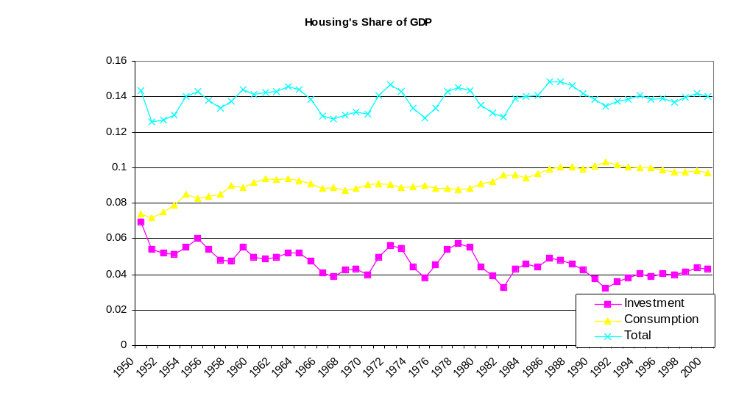Exhibit 1
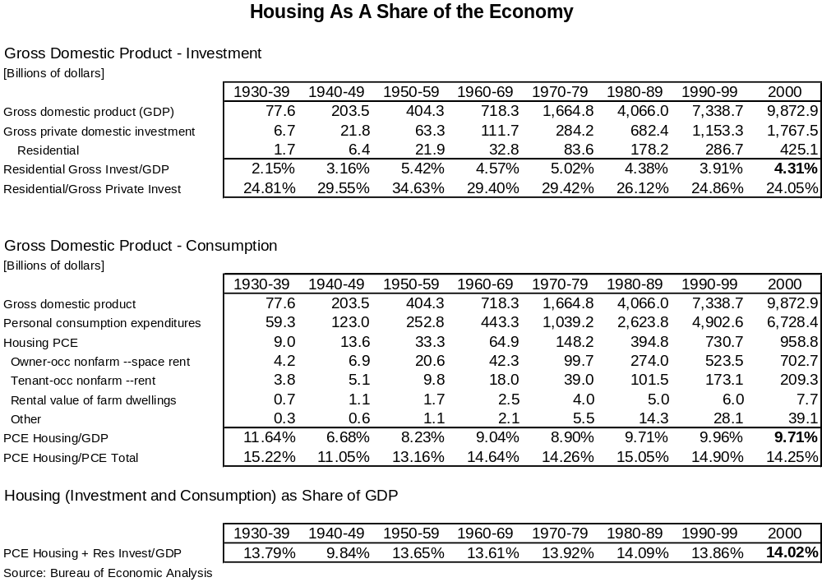Exhibit 2

Local Economic Impact
The economic impact of home building is also felt at the local level. When home construction occurs in a particular community, positive impacts begin before the first shovel hits the dirt. The impacts continue as long as the home is occupied by household purchasing locally produced goods and services or generates more property tax revenue than the raw land would.

The ongoing effect of consumer spending by the household in the unit, which is often overlooked, can be especially powerful at the local level. Nationally, the income and spending of new home buyers would be part of the economy wherever they lived (as long as they remain in the country), so that only the above-normal levels associated with a recent home purchase represents a net increase. To the extent that a new home attracts an additional household into a community (or prevents one from moving away), however, all of that household’s purchases of goods and services from local businesses counts as a net benefit to a particular community.

NAHB’s local economic impact model was designed specifically to estimate all of these benefits. NAHB developed a computer model to measure the local economic impact of building a home within the boundaries of a particular local market area. The model is divided into three phases. Phase I includes the jobs, wages, and local taxes and user charges and fees generated by the actual development, construction, and sale of a home. Phase II includes the wages and profits distributed during the construction period and spent by local workers and business owners on locally supplied goods and services. The continuing effects from recycling income back into the community produces more jobs, wages and local taxes in the community. Phase III tracks the roughly 30 percent of the new home occupant’s income that is spent on items produced by local businesses. In turn, that spending causes its own ripple as local businesses and workers buy from other local business. The impact of a new household causes a permanent increase in the level of economic activity, jobs, wages, and local tax receipts.

Although the model incorporates information from many sources, a large share of the information about national average economic activity comes from the input-output tables and National Income and Product Accounts produced by the Bureau of Economic Analysis. In order to customize the model to a specific local area, the model uses local government accounting information from the Census of Governments, produced by the U.S. Census Bureau, as well as information collected directly from the local area.

Income and Jobs

The model estimates that the construction of 100 single family homes generates $10.7 million in new income to local business and workers in the year of construction and another $2.9 million every year thereafter. Building 100 new homes creates 257 jobs in the community where the homes are built and 75 every year thereafter in support of the new households. In 10 years, the local economic impact of building 100 single family homes is $37 million.

Similarly, construction of 100 multifamily units generates $5.2 million in local income in the year of construction and another $1.8 million every year thereafter. This translates into 122 jobs the first year and 46 additional jobs year thereafter. In 10 years, the local economic impact of building 100 apartments is $23 million.

The economic and job impacts are broad. As might be expected, the construction sector accounts for a substantial share of the economic impact in the year of construction-$5.8 million in the case of 100 single family homes. Wholesale and retail trade activity increases by $1.5 million, and business and professional services add $737,000 to their income statements when 100 homes are built. But even the service industry feels the effect as workers and businesses spend their new incomes on the local economy and that stimulus generates another wave and so on and so on. The proportional impacts of multifamily construction on various local industries are similar. A full description of the industries affected is shown in Exhibit 3.

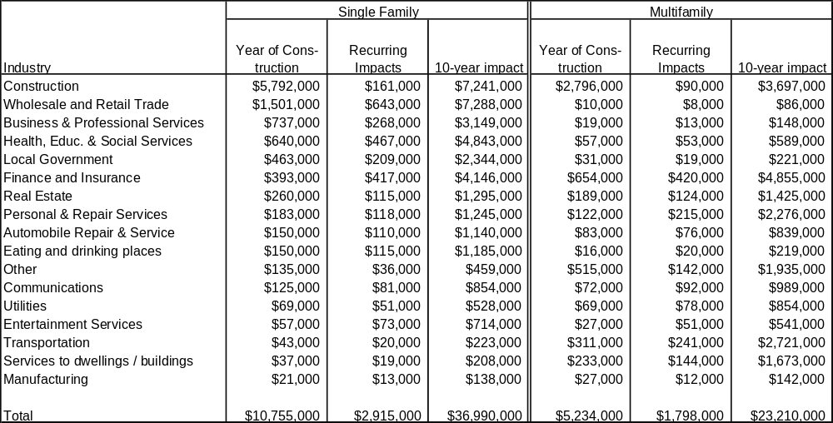Exhibit 3
Local Income Generated by Building 100 Homes

Source: NAHB Local Economic Impact Model for a typical metropolitan area

Taxes and Other Revenue for Local Governments

Local governments realize new revenues as well, as builders pay fees and as businesses expand and pay fees and taxes. Building 100 new single family homes generates additional taxes and other revenues to the local government in the amount of $1.2 million in the year of construction and $472,000 every year thereafter. Similarly, 100 new multifamily units generate $579,000 in local government revenue the first year and $308,000 every year thereafter.

Permit and impact fees are the largest component of local government revenue generated during the construction period, totaling $535,000 for every 100 single family and $270,000 for every 100 multifamily homes in a typical community. As most people would expect, residential property taxes are the largest component of ongoing effect, totaling $177,000 for every 100 single family and $106,000 for every 100 multifamily homes built.

Even at this, residential property taxes account for only a little over one-third of the ongoing impact. Other sources of new revenue for local governments include fees, charges paid to government owned enterprises such as utilities, and business property taxes. Exhibit 4 contains a full accounting.

Exhibit 4
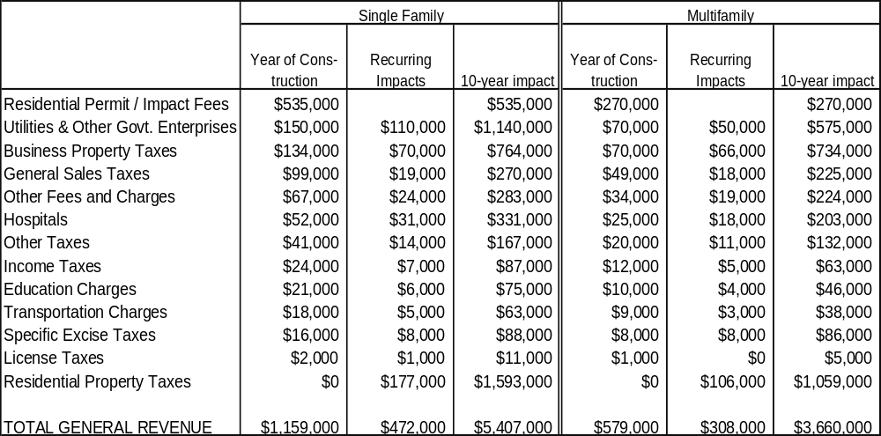Local Government Revenue Generated by Building 100 Homes
Source: NAHB Local Economic Impact Model for a typical metropolitan area

Other Benefits to the Community

Local governments will, of course, spend the additional revenue generated by home building. Some of it will be used to fund new school construction, some of it helps pay for new parks and police cars, and some of it is used to build new community centers. In short, new homes create new communities.

As such, home building is a necessary complement to other types of development. New homes not only help to create and sustain jobs in construction, retail trade, and services, they provide places to live for workers in other industries.

Unfortunately, in many cities across America the number of new homes being built is not keeping up with the number of new jobs being created. Absent sufficient new home construction, existing home prices rise and millions of Americans become priced-out of the local housing market; no longer able to afford to buy a home where they work. This is precisely what is occurring in large parts of California. In places like San Francisco government workers such as policemen, firefighters and elementary school teachers are unable to buy a home near where they work. As a result, these communities lose the positive and steadying influence these people encourage, making these neighborhoods less stable and less safe than they would otherwise be. In addition, these workers often face very long commutes, less time with their family, and irregular work schedules.

Fortunately, in most areas of the county new homes are being built and new communities continue to spring up. Interestingly, most new homes are being built in the suburbs. While some citizens are concerned about this trend and fear that if continued it will do harm, the fact is homes are generally built where jobs are being created. During the nine years ending August 2001 total employment in the top 50 metropolitan cities grew by 8.5 million jobs and two out of every three of these jobs were located in the suburbs. Central city employment grew by 2,731,172 jobs, or 14.8 percent, while employment in the suburbs of those same cities grew by 5,757,389 jobs or 20.2 percent. During the same time period nationwide employment growth in all metropolitan areas was 15.6 million and two-thirds of that increase, or 10.4 million jobs, took place in the suburbs.

Given a reasonable amount of freedom, builders will build the type of homes their prospective customers want in areas that are desirable, which most frequently means the suburbs. Slowly but steadily employment and housing are moving from central cities to the suburbs. As a result, home construction, not to mention retail and commercial establishments, necessarily follow. Commuting patterns across America are changing and homebuilders, like any successful business, have responded to these changes by providing desirable housing with attractive amenities in popular and sought-after locations. Were it any other way, many builders would go bankrupt, many construction workers would lose their jobs, and many homes would be built far from employment centers. This would result in buyers having longer commutes and being forced to live in less desirable locations.

Social Impacts of Housing
Homes provide an economic impact on the national economy and on local economies. Homes provide places for job-holders and their families to live near where they work. Homes also provide a social fabric that improves the community, provides benefit to the residents and neighbors and economizes on fiscal costs. An array of evidence from numerous sources supports the claims of social benefit from owned and rented homes.

Homeownership

In addition to creating jobs, increasing tax revenues, boosting profits and adding to the overall income of a geographic area, home ownership increases the social capital of a community. While sometimes difficult to quantify, increases in social capital benefit and improve the entire community, just like the financial and fiscal impacts of home ownership do. To the extent that home owners are more actively involved in the PTA the public schools benefit. Similarly, the owner-occupants more readily join neighborhood watch groups the more crime is reduced and the less the police are burdened, and to the extent that home owners spend more time with their children all of society gains. The critical issue is that the benefits from all these activities help others and improve our neighborhoods and communities.

The view that home ownership provides benefits to communities in addition to individual homeowners is quite pervasive. This is often the justification for government sponsored home ownership programs. The social benefits of home ownership are thought to include improved outcomes for children of home owners, increased involvement in civic affairs, and better maintenance of their homes and neighborhoods.

Until recently the social benefits to home ownership have simply been taken for granted. This is partly because there has been no empirical evidence either supporting or discrediting these long-held claims. Of late, a large number of academic studies conducted by demographers, sociologists, psychologists, and economists have been published that have consistently corroborated the view that the benefits of home ownership extend to the greater community.

To be more precise, all the papers published in this area find at least one, and in many cases several of the following: improved outcomes for children, increased civic involvement, greater neighborhood stability, a better sense of well-being, increased savings and wealth, and many other beneficial outcomes. The papers reviewed here are no exception. In isolation, these findings could be dismissed, attacked or discredited. Collectively, however, the weight of the evidence, the breadth of the disciplines, the variety of data sets, and the many time periods studied strongly suggests that intuition was right and that the benefits of homeownership, do indeed, extend beyond the homeowner.

Two papers have explored the impact of home ownership on children. In a recent paper Haurin, Parcel and Haurin found that that home environments and child outcomes are better for children raised in homes that are owned. In particular, they found the cognitive stimulation/physical environment to be 22 percent higher, and the emotional environment to be about 16 percent higher. As far as outcome measures are concerned, math scores were found to be seven percent higher, reading scores to be six percent higher and an index of behavior problems to be about four percent lower. Since their data was longitudinal, they also found that the longer the household owned the home, the higher the environmental and outcome measures were.

Green and White found that children raised in owned homes are more likely to stay in school, teenage daughters are less likely to have a child, and adolescents are less likely to be arrested. To be specific, three to five percent more seventeen-year-olds living in homeowning families will stay in school compared to identical seventeen-year-olds living in rented homes. Similarly, 15 percent fewer teenaged daughters living in owned homes are likely to become pregnant before age 18 compared to otherwise similar adolescents girls of renters. Lastly, these authors found that adolescents from homeowning families had lower arrest rates than equivalent adolescents living in a rental facility.

In a detailed analysis using two national data sources Rossi and Weber found owners to be consistently more engaged in local politics than renters because owners believe that local elections are important. Proportionately, more owners participated in groups that “tried to solve local problems,” and were more likely to have held leadership and activist positions in local improvement groups. Their results showed higher levels of owners serving on group committees, attending group conferences, serving as group officers, and donating funds beyond membership dues. They also found that owners are more likely than renters to have participated as voters or activists in national elections, to have lobbied state and federal officials, and to have given money to support candidates.

Separately, over a 12-month period Rohe and Stegman studied the neighborhood social and political involvement of 140 low-income persons who had recently become homeowners and a comparison group of low-income Section 8 renters from the same population. A year after moving into their new dwellings, the owners were more likely than the comparison group to participate in neighborhood organizations.

A paper by Glaeser and Sacerdote shows that homeowners are about 12 percent more likely to vote in local in local elections than otherwise similar non homeowners. They also report that homeowners are seven percent more likely to “work to solve local problems” compared to otherwise statistically identical renter voters.

In their research Rossi and Weber also found that with homeownership comes a small yet consistent improvement in one’s sense of well-being. Their research shows that owners are higher than renters in measures of self-satisfaction, and are more likely to believe that they can do things as well as anyone else. In addition, owners are “more sure that their lives will work out as they want, score lower on a scale of depression, show higher levels of happiness with life in general, and rate themselves higher in physical health.”

In addition to asking questions about civic and political involvement, Rohe and Stegman also asked the small group of new owners and the comparison group of Section 8 renters questions about life satisfaction, self-esteem, and perceived control over their lives. Their results corroborated the results of Rossi and Weber. Rohe and Stegman reported that new owners were more satisfied, had higher levels of self-esteem and felt they had more control over their lives than renters.

It cannot be ruled out that the above mentioned findings may simply be due to factors that are correlated with owning a home. For example, homeowners tend to be older, wealthier, and are more likely to be married and have a college degree than renters. However, given the thoughtful and elaborate statistical approaches taken by the researchers and the numerous control variables used, these analyses strongly suggest that the differences reported are due to moving from renting to owning and not due to attributes correlated with those decisions.

A report published by the Department of Housing and Urban Development reported “equity in a home is the largest single source of wealth for most families and marks an increasingly important economic divide in American society. Median net worth for homeowners exceeds $78,400 compared to $2,300 for renters. More than 60 percent of homeowners’ wealth is in the form of home equity.”

A relatively recent article corroborated the findings mentioned in the previous paragraph and offered some insight into why homeownership and wealth are so highly correlated. By studying youth ages 20 to 33 for the years 1985 through 1990 Haurin, Hendershott and Wachter observed that wealth increases by a third in the year before first ownership, generally doubles during the year a house is purchased, and continues to grow on average by 17 percent after first ownership. These are all rates substantially in excess of those experienced by renters. Prior to homeownership and during the year of first ownership the authors contend that marriage and an increase in the number of hours worked for women, and to a less extent men, are prime reasons for increases in household wealth. Also, about 14 percent of first time buyers receive gifts from family with an average value of $5,224. The authors speculate that the high growth rate of wealth following first ownership probably reflects the highly leveraged investment in an appreciating asset. In short, homeownership is highly correlated with thrift, hard work, and marriage.

Positive Aspects of Multifamily Development
Although there are certain advantages to owner-occupied single family detached homes, a community requires an adequate supply of all types of housing, including multifamily rental units. Multifamily housing is generally needed to accommodate people who are at certain stages of their life cycles, and people who desire to remain mobile for employment or other reasons. Multifamily units also tend to accommodate people who desire to live near certain businesses or public facilities. In addition to the need for multifamily housing, denser apartment buildings have smaller fiscal impacts on the community, including less demand on schools, fewer and shorter car trips, and no negative impact on surrounding property values. The proximity of multifamily homes also promotes a sense of community.

Schools

The cost of public education is usually the largest local government expenditure. According to the 1997 Census of Governments, of the $828 billion spent directly by all local governments in the U.S., $307 billion was spent on education. The lion’s share—$292 billion—was spent on elementary and secondary education (by comparison, local governments spent a total of only $21 billion on housing and community development.)

Multifamily units and the households in multifamily units have a lower level of demand for local schools. As Exhibit 5 shows, there are only 36.7 school-aged children per 100 occupied multifamily units in the U.S. compared to 62.4 for single family detached homes. The number of school-aged children tends to be even lower in larger apartment buildings—only 28.6 school-aged children per hundred units in structures with at least 20 apartments, compared to 45.4 in 2-4 unit structures.

Exhibit 5 also shows some interesting relationships between structure type and other variables. Households moving into new single family detached homes have noticeably more school-aged children than non-movers living in the same type of structure. The difference shrinks slightly if the structure is new, but households moving into new single family detached homes still have more school-aged children than non-movers—68.1 per 100 households vs. 61.3. In multifamily housing, on the other hand, the difference between movers and non-movers is very small, and households moving into new apartments actually have fewer school-aged children than the corresponding non-movers—31.8 per hundred vs. 36.5. Owners of multifamily homes have even fewer school-aged children than renters in multifamily buildings.

Commuting and Traffic

Multifamily housing also imposes less of a burden on local government expenditures for road construction and maintenance. Tabulations of the 1999 American Housing Survey (AHS) show that 9.2 percent of renters who moved recently chose neighborhoods because they were located near public transportation. This may seem like a small share, but is more than two and a half times higher than the equivalent figure for households buying single family detached homes during the same period. Related statistics are available from the 1990 Census. The Census showed that, compared to single family residents, multifamily residents were substantially less likely to contribute to rush hour traffic by driving to work, and more likely to use public transportation. The American Housing Survey tabulations also show that multifamily renters are more likely to choose a neighborhood to live in because it’s situated near their place of work.

A standard reference for road use statistics is the 6th edition of Trip Generation, published by the Institute of Transportation Engineers, which compiles data from roughly 4,000 transportation studies conducted by public agencies, developers, consulting firms, and associations. The compilation includes the average number of trips (vehicles entering or leaving a site) generated by different types of land developments, including several categories of multifamily projects. Average trips per day and, during peak travel times, per hour are given.

The results in Exhibit 6 clearly show that, compared to a single family home, an average multifamily unit generates fewer trips. For example, on weekdays a single family detached home generates 9.57 trips, compared to 6.63 for a rental apartment and only 4.2 for an apartment in a high-rise (more than 10 stories tall) building. Of perhaps greater interest to city planners is the number of trips generated during rush hours, when local streets are most congested. Here again the multifamily numbers are considerably lower. Where a single family home generates 1.01 trips per evening rush hour (peak hour of street traffic between 4 and 6 P.M. on weekdays), an average rental apartment generates only 0.62, and an average high-rise apartment only 0.35.

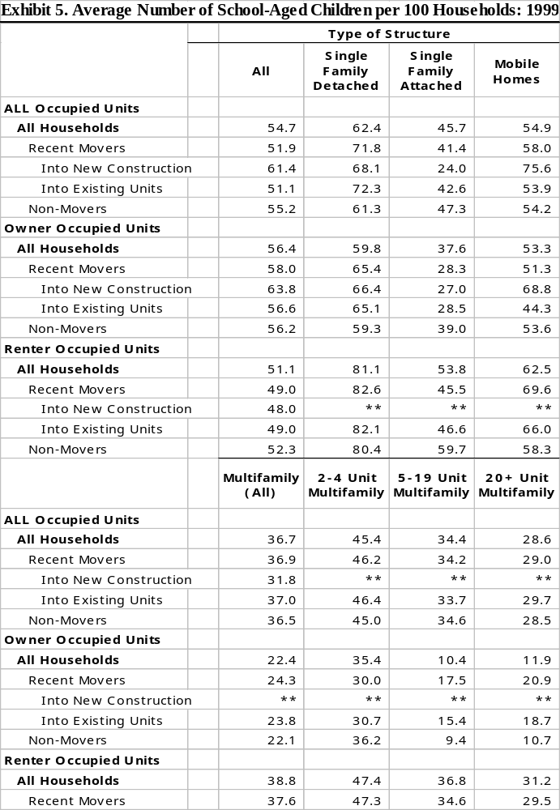Source: 1999 American Housing Survey as compiled by NAHB

Exhibit 6. Average Number Of Vehicle Trips Generated Per Dwelling Unit
 | Single Family Detached Housing | Rental Apartments In Buildings With At Least 4 Units | Low-Rise Rental Aprtments (One Or Two Stories) | Mid-Rise Rental Aprtments (Three To Ten Stories) | High-Rise Rental Aprtments (More Than Ten Stories) | Condominium Apartments And Townhouses | Low-Rise Condominium Apartments And Townhouses (One Or Two Stories) | High-Rise Condominium Apartments And Townhouses (More Than Two Stories) | Condominium Apartments And Townhouses With Luxury Features Or Services
Weekday | 9.57 | 6.63 | 6.59 | NA | 4.20 | 5.86 | NA | 4.18 | NA
Weekday During Peak Hour of Traffic on Adjacent Street Between 7 And 9 AM | 0.75 | 0.51 | 0.47 | 0.30 | 0.30 | 0.44 | 0.66 | 0.34 | 0.56
Weekday During Peak Hour of Traffic on Adjacent Street Between 4 And 6 PM | 1.01 | 0.62 | 0.58 | 0.39 | 0.35 | 0.54 | 0.83 | 0.38 | 0.55
Weekday A.M. During Peak Hour of Traffic Entering And Exiting the Site | 0.77 | 0.56 | 0.51 | 0.35 | 0.34 | 0.44 | 0.51 | 0.34 | 0.65
Weekday P.M. During Peak Hour of Traffic Entering And Exiting the Site | 1.02 | 0.67 | 0.62 | 0.44 | 0.40 | 0.54 | 0.54 | 0.38 | 0.65
Saturday | 10.09 | 6.39 | 7.16 | NA | 4.98 | 5.67 | NA | 4.31 | NA
Saturday During Peak Hour of Traffic Entering And Exiting the Site | 0.94 | 0.52 | 0.58 | NA | 0.40 | 0.47 | NA | 0.35 | NA
Sunday | 8.78 | 5.86 | 6.07 | NA | 3.65 | 4.84 | NA | 3.43 | NA
Sunday During Peak Hour of Traffic Entering And Exiting the Site | 0.86 | 0.51 | 0.56 | NA | 0.31 | 0.45 | NA | 0.30 | NA
Source: Trip Generation, Institute of Transportation Engineers, 6th edition.

Property Values

Contrary to popular perceptions, multifamily projects do not have an adverse impact on surrounding property values. Data from the AHS provide the evidence.

The AHS is based on a panel of housing units that the Census Bureau revisits every two years. The Bureau collects information about the value of single family homes and characteristics of the area around the homes—including the presence of different types of structures. Hence, by comparing the values of the same home in different years of the AHS, it’s possible to calculate annual appreciation rates both for homes that were near multifamily structures and those that were not.

The information about the value of a home in the AHS comes not from a recorded sale, but the owner’s estimate of how much the property is worth at the time of the survey. Some may wonder if home values determined this way are accurate. Several academic studies have looked at this issue. The studies invariably find that, although owners’ estimates of value are not completely accurate, they tend to be overstated by a percentage that does not vary in any systematic way with characteristics of the either house or the people occupying it. This implies that appreciation rates computed from these values will generally be unbiased. (Increasing a unit’s value by, say, 6 percent in both 1997 and 1999 will not change the rate of appreciation measured between those two years.)

The AHS data about the area immediately surrounding a housing includes multifamily structures within a half block (currently defined as approximately 300 feet for respondents who have trouble determining how far a half block is). The data also identify if the nearby apartment buildings are low-rise (fewer than four stories tall), mid-rise (four to six stories), or high-rise (seven or more stories). This information can be used to compute average annual appreciation rates for single family homes that were and were not near multifamily buildings at the start of the period. Results are reported in Exhibit 7. Due to changes in the way the Census Bureau collected neighborhood data over the years, the table splits the results into two periods—reporting appreciation rates separately for 1987-1997 and 1997-1999.
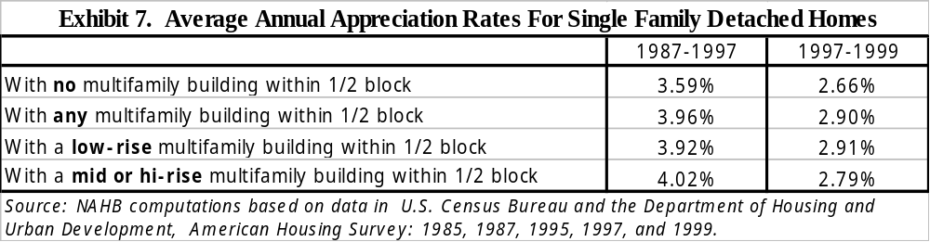

Although the average annual appreciation rates are somewhat lower for 1997-1999 than for the earlier period, the impact of nearby multifamily structures is similar in both instances. Between 1987 and 1997, single family detached homes that were located near multifamily structures in 1987 appreciated at a slightly higher rate (a little over 3.9 percent per year) than single family detached homes that were not near multifamily buildings (approximately 3.6 percent). This was true whether the nearby multifamily buildings were low-rise, or mid- to hi-rise (there were not enough observations to separate the mid- and hi-rise cases). In fact, the near mid- or hi-rise cases at even a slightly higher rate than the home near low-rise apartment buildings.

Between 1997 and 1999, single family detached homes that were located near low-rise multifamily structures in 1997 appreciated at a slightly higher rate than those near taller apartment buildings (2.9 percent compared to about 2.8 percent). But again, homes in both these categories appreciated at a somewhat higher rate than homes that were not near multifamily structures.

For a given time period, the differences in average appreciation rates are small and shouldn’t be interpreted as proof that apartment buildings actually increase the appreciation of single family detached homes in an area. The bottom line is that, contrary to the relatively common assertion, the AHS provides no evidence that multifamily buildings reduce the value of nearby single family homes.

Sense of Community

The Glaeser and Sacerdote paper previously cited attributes certain social benefits to multifamily structures. In particular, they find that multifamily structures appear to lead to more social interactions among neighbors. One reason this might occur is that, in apartment buildings, there is on average less distance between residents. Reduced distance suggests that the cost of making social contact with neighbors will be lower. Glaeser and Sacerdote are able to cite a substantial body of academic literature demonstrating that even modest increases in distances may seriously decrease social interaction.

A related argument is driven by the tendency of multifamily units to be smaller than single family homes. When living in smaller living units, the argument goes, public spaces outside of the home will seem comparatively more desirable. If apartment dwellers consequently go out to eat or drink or recreate more often, this also could lead to more social interactions with neighbors. Indeed, when they investigate this empirically, Glaeser and Sacerdote find that individuals who live in apartment buildings are much more likely to spend an evening out with someone from the neighborhood. They also find that people living in apartments are more likely to visit a tavern, something they interpret as a measure of socializing in public spaces outside of the home. In other data based on a survey that asked slightly different questions, they find that apartment dwellers are more likely to spend the night out and to attend cultural events. These effects are stronger and statistically more significant for people living in large (10 or more unit) apartment buildings.

Glaeser and Sacerdote conclude that these results are important because they confirm their hypothesis that apartment buildings are associated with a sense of community rather than anonymity.

Conclusion

Housing’s impact on the economy and daily living is extensive and large. Policies promoting housing, policies providing incentives and assistance and policies acknowledging the extensive impacts of housing should be promoted because their consequences extend far beyond simply increasing the investment component of GDP.

This paper has reviewed the macroeconomic impacts of home building, remodeling, transacting and using. Over 14 percent of the economy involves housing related outputs. At the local level, constructing and then providing a home produces significant local economic activity that lives on as the new residents live and shop in their community. Homes provide a social fabric for their occupants to live and interact with their neighbors and community. Homeownership appears to promote other positive social outcomes, especially for children and multifamily homes exert less fiscal demand on their local government budgets.

Endnotes

Appliances purchased by home owners are included in personal consumption expenditures, rather than residential investment.
Emrath, Paul. “What Else Home Buyers Buy”, Housing Economics, April 2000. p. 6-10.
Employment Statistics for Selected Cities and their Metropolitan Areas", Bureau of Labor Statistics.
Haurin, Donald R., Toby Parcel, and R. Jean Haurin. 2000. “The Impact of Home Ownership on Child Outcomes,”
Green, Richard K. and Michelle J. White. 1996. “Measuring the Benefits of Homeowning: Effects on Children.” Journal of Urban Economics 41: 441-461.
Rossi, Peter H., and Eleanor Weber. 1996. “The Social Benefits of Homeownership: Empirical Evidence from National Surveys,” Housing Policy Debate 7 (1): 1-34.
Rohe, William M., and Michael A. Stegman. 1994. “The Effects of Homeownership on the Self-Esteem, Perceived Control, and Life Satisfaction of Low-Income People.” Journal of the American Planning Association 60 (2): 173-184.
Glaeser, Edward L. and Bruce Sacerdote. 2000. “The Social Consequences of Housing.” Harvard Institute of Economic Research, Discussion Paper 1915.
Department of Housing and Urban Affairs, 1995. “Urban Policy Brief Examines the Advantages of Homeownership.” Recent Research Results November 1995.
Haurin, Donald R., Patric H. Hendershott, and Susan M. Wachter 1996 “Wealth Accumulation and Housing Choices of Young Households: An Exploratory Investigation.” Journal of Housing Research, 7 (1): 33-57
See Goodman J.L. and J.B. Ittner, “The Accuracy of Home Owners’ Estimates of House Values” Journal of Housing Economics, 1992; DiPasquale, D. and C.T. Somerville, “Do House Price Indices Based on Transacting Units Represent the Entire Stock? Evidence from the American Housing Survey,” Journal of Housing Economics, 1995; and Kiel, K.A. and J.E. Zabel, “The Accuracy of Owner-Provided House Values: the 1978-1991 American Housing Survey,” Real Estate Economics, 1999.
Calculating appreciation rates requires several adjustments to the AHS data. To preserve confidentiality, the Census Bureau truncates the highest priced homes on the data it releases to the public. The data set also contains occasional coding errors, such as a missing digit in a figure that has several zeros at the end. Because average appreciation rates can be very sensitive to a few bad observations, it’s important to screen out as many of these as possible. To do this, observations were dropped if the values were truncated or fell to less than 50 percent of the value reported in the previous survey before appreciation rates were computed. After they were computed, observations were dropped if the annual rate was more than 20 percent or less than negative 20 percent before averages were calculated.
Prior to 1987, Census Bureau interviewers recorded this information on-site. Beginning in 1987, however, the Bureau started to replace some personal interviews with telephone interviews. When the interviews were conducted over the telephone, the information about multifamily structures nearby was not recorded. Conversations between NAHB and the Census Bureau have not cleared up all the questions about how the data was coded in these cases, but it appears fairly certain that a “1” always means there is a multifamily structure nearby, regardless of the year of the survey. When something other than a “1” appears in this data field between 1987 and 1995, it’s not clear if it indicates the absence of a multifamily structure nearby, or that this information was simply not recorded because it was a telephone interview. The 1987-1997 appreciation rates for single family homes that are near apartment buildings should thus not be impacted at all by any of these coding problems. However, the 1987-1997 appreciation rates for homes not near apartment buildings are almost certainly contaminated by some observations where the home was near an apartment building in 1987, but where we couldn’t determine this from the AHS data. Because the presence of multifamily buildings near owner-occupied single family detached housing is a relatively rare event, however, the percentage of contaminated observations should be fairly small and unlikely to alter the computed results in a significant way. In 1997, AHS data collection procedures changed again as the Census Bureau introduced new computer-assisted techniques. Interviewers now ask respondents to report if there are multifamily buildings within half a block. Although some no doubt would still prefer to have this information recorded directly by on-site, well-trained government employees, the 1997 and 1999 AHS data sets should be free of the above mentioned coding problem.

