ATTACHMENT A

The Housing Pinch

By William Fulton and

Paul Shigley

There's nothing ordinary about a political rally that begins with a group of pastors issuing an apology for not paying enough attention to the issue at hand. Nor is a speech by state Treasurer Phil Angelides typically interrupted by a chorus of "hallelujahs."
Then again, there is nothing typical about the overheated housing market in San Francisco - and elsewhere in the state - a housing market where so many people earning $50,000 a year qualify for local housing assistance that the programs routinely have to turn residents away.
It's that kind of housing frustration that prompted the unusually passionate outpouring last February at a San Francisco rally to support affordable housing - an issue that increasingly resonates in a number of congested areas statewide.

From San Francisco to San Diego, California is growing too many jobs for too few houses. The result is a housing market that has spiraled out of control. But the statewide clamor for more affordable housing has reached the Legislature, where a bumper crop of housing bills are awaiting lawmakers' attention.

"We acknowledge our shame at the treatment of the poor and vulnerable people in this city and area," said the apology signed by dozens of San Francisco clergy members and read aloud at the rally. "And we confess our shame that we have learned to live with the degradation and displacement of poor and

working-class people and that we have enabled our people to put up with it."
The February rally - which attracted 3,000 people on a Sunday afternoon - concluded with Angelides, State Senate President pro Tempore John Burton (D-San Francisco) and state Assemblyman Kevin Shelley (D-San Francisco) all pledging to fight for continued funding for new construction, rental assistance, down-payment help and older home rehabilitation, as well as increased housing tax credits and a "Renters' Bill of Rights" to limit rent-based evictions by landlords.
"We didn't just want it to be this rally where people come and scream and go home, and nothing has happened, " explained Denise Collazo, executive director of the San Francisco Organizing Project, a federation of 40 religious congregations from across San Francisco.
Collazo's group was confronted by the housing issue while conducting hundreds of interviews last year during its annual survey of city residents. Health care and transportation had been the top priorities in recent surveys until last year when the group found that tenant evictions had "skyrocketed," leaving nearly everyone interviewed worried about whether they, their family members and their friends could continue to live in a city where tiny studio apartments rent for $1,500-a-month and up.
"Two years ago, the number one issue in the city was Muni," Collazo says, referring to San Francisco's beleaguered bus system. "Now, people go, 'Muni? Huh?' Even middle-class families can't afford to live in San Francisco.... There is a whole segment of the population that's leaving, and it's mostly families with children."
The San Francisco rally is just one example of the political pressure placed on state lawmakers to do something about housing statewide. Although the electricity crisis has dominated the Capitol's agenda for months, legislators this year have introduced a record number of bills - roughly 150 by one count - concerning housing.
"I think there are easily twice as many bills as we normally see," said Mike Herald, executive director of Housing California, a coalition of advocacy groups. "I think it's a reflection of what members are hearing in their districts."
Senator Joe Dunn (D-Santa Ana), chairman of the Senate Housing and Community Development Committee, said housing is on every lawmaker's radar screen this year. "It's not just a Silicon Valley problem. It's really starting to touch every portion of the state," said Dunn.
The state's affordable housing problem is well documented. Since the mid-1990s, a number of California communities, particularly in the Bay Area, Silicon Valley, Orange County and San Diego, have created new jobs far faster than new housing, causing home prices to rise dramatically.
During the past decade, housing production has lagged. According to the California Building Industry Association, 1.67 million homes should have been built since the beginning of 1994. However, only about 800,000 housing units have been constructed. In most of the Bay Area, only about one family in six can afford the median-priced house. In portions of Southern California, the ratio is not much better. In many congested areas, especially in Los Angeles, families are doubling up, sharing a household as a means of stretching their housing dollars.
Legislators have proposed a number of solutions to attack the housing crisis. Among them are bills to construct more housing near work places for all income levels, while other measures focus strictly on building apartments and houses affordable to low- and middle-income residents. Some bills would streamline the environmental review process for "infill" developments. Some would provide tax incentives to local governments that approve new housing. Another measure would strengthen the "anti-NIMBY [Not In My Backyard]" Iaw so that cities and counties have legal cover when they approve affordable housing projects. There also is a proposal for mortgage guarantees for people who purchase homes in urban areas, and several proposals that single out fire fighters, police officers, teachers and other public employees for housing assistance. Another bill would require redevelopment agencies to spend more tax increment revenues on housing. There also are bills to decrease builders' liability for construction defects, which developers contend has prevented widespread construction of condominiums and townhouses.

Taxing hurdles
One of the biggest hurdles to more local housing construction is that cities and counties are often reluctant to approve building permits for new housing, compared with office or commercial space, because the state's system of financing local government emphasizes a reliance on sales tax revenue over property taxes. This so-called "fiscalization of land use" was exacerbated during the early 1990s when th state shifted a portion of property taxes away from cities and counties to fund school districts.
Four years ago, a prominent group of Iand-use planners called the California Planning Roundtable issued a report, "Restoring the Balance," which concluded, in part, "Many local governments have no incentive to approve much-needed housing projects -- especially affordable housing projects -- because they are money-losers for the local budget."
Janet Fairbanks, a roundtable member and senior regional planner for the San Diego Association of Governments, says little has changed on affordable housing since that report was issued. "Given the energy problem right now, it doesn't seem to be receiving the attention it was getting [in the Legislature]. But it's still a concern to us," she said.
Fairbanks' concerns are not forgotten, according to Assemblywoman Patricia Wiggins (D-Santa Rosa), who chairs the Assembly Local Government Committee and the Assembly's Smart Growth Caucus.
"Many of us are looking at property tax incentives. We're not going to get a wholesale return of the property tax that was shifted away, but we can do it in pieces," Wiggins said. Both she and Assemblyman Alan Lowenthal (D-Long Beach) are carrying legislation -- AB 859 and AB 1284, respectively -- that would give cities and counties a larger share of property tax revenues. Lowenthal's measure specifically targets communities with serious jobs-housing imbalances.
Dunn, however, says it is "not likely" that any proposal shifting property tax money from the state to cities and counties will get approved this year because the state has spent so much of its surplus purchasing electricity.
"It's one of those things that everybody sees as a problem," Dunn says. "Whatever changes we make, we're going to create some new winners and some new losers. That zero-sum game has paralyzed discussion here at the Capitol."
One of Dunn's major efforts this year (SB 910) would put teeth in the state's housing element law, which requires cities and counties to specify in their general plan how and where they will locate affordable housing. Under the current system, there are few penalties for cities and counties that fail to adopt valid housing elements, and Dunn estimates that one-third of cities and counties do not comply with the law. His bill would: give better legal footing to housing advocates who challenge a local housing element in court, impose fines and, most important, withhold state transportation dollars from cities and counties that don't comply.
"That is going to be a shot at the heart of the jurisdictions that steadfastly have refused to comply with the housing element law," Dunn says.
Dunn's bill is adamantly opposed by both the League of California Cities and the California State Association of Counties. In its recent legislative bulletin, CSAC said Dunn's bill is "a very punitive measure that ignores the fiscal realities" needed to provide affordable housing in California. "The housing crisis is not an independent problem and cannot be solved through a microscopic approach such as the 'housing element,’” according to CSAC's bill analysis.
Sunne Wright McPeak, president and CEO of the Bay Area Council, an association of business executives, says the state's housing element law needs carrot-and-stick incentives.
"There is nothing in housing element law mechanisms that allows the markets to operate as they should and meet the full demand," says McPeak, who also chairs Job Center Housing Coalition, a collection of business, labor, minority and housing groups.
But McPeak blames the state's lack of land-use planning for the failure of cities and counties to meet housing demands. "We don't have a firm state housing policy for meeting the needs of the work force," she complains.
Under the current system, the state Department of Finance estimates the number of new housing units the state will need to accommodate its growing population. The Department of Housing and Community Development then negotiates with regional councils of government (COGs) -- such as the Southern California Association of Governments and the Association of Bay Area Governments -- to determine what type and how many housing units each region will provide. The COGs then assign each city and county in their region a "fairshare" number: specifying how many very low-, low-, moderate and above-moderate income housing units will be located in each jurisdiction. The process is always contentious, and the latest round in Southern California has resulted in litigation amongst cities, counties, SCAG

and the state over where affordable housing should be located.
Susan Baldwin, senior regional planner for the San Diego Association of Governments (SANDAG), said local governments need financial incentives to comply with the housing element law. She also suggested the state require cities and counties to issue a certain number of building permits for affordable housing each year, rather than simply issue a plan on paper.
Like many people, Baldwin says that subsidies are essential for creation of affordable units.
"A lot of it is having actual money or tax incentives to make it happen. The low-income tax credit program has been tremendously successful and is oversubscribed every year," Baldwin says.
To resolve that, Dunn has a bill (SB 73) that would increase the number and total amount of state tax credits available for those investing in low-income housing development.
Sande George, lobbyist for the California Chapter of the American Planning Association, also says that if lawmakers want to encourage affordable housing, they need to provide financial assistance. Affordable housing only pencils out, she said, when there are economic subsidies.
The 2000-01 state budget contained a record $570 million for housing programs, up from nearly zero during the Wilson and Deukmejian administrations. Last year was the first budget in at least 20 years that set aside significant amounts of funding for housing. But most of that was one-time funding, and there is great doubt that the next budget will earmark anywhere near as much - despite promises by Angelides, Burton and others at political rallies.
Housing California's Herald says his priority is getting the state to provide more money for housing production, especially construction of units for the poorest families. He also is concerned about the roughly 100,000 rental housing units statewide that are at risk of losing their subsidized, low rental rates in coming years. Under the federal government's "Section 8" housing program, these units allow tenants to pay below-market rental rates, with the balance paid to landlords by the federal government. But as these federal contracts expire, many landlords allow their rentals to revert to full-market prices, causing rents to skyrocket.
A bill by Dunn (SB 372) would provide interim financing allowing the state or a nonprofit agency to purchase Section 8 units to maintain their affordability. Dunn also is lobbying Congress to reverse a 1986 tax change that discouraged investment in apartment buildings and other rentals.
Still, building more affordable housing is nearly everyone's priority. The building industry estimates California should have built twice as many new homes during that '90s than were actually constructed.
"As we see it," said the Bay Area Council's McPeak, "we've got an affordability problem and an availability problem, and the availability problem is at the heart of the affordability problem. We've got to get more real, so to speak, on the supply side of things."
The lack of construction is often blamed on NIMBYism - the "Not In My Back Yard" protests of citizens and elected officials. In recent years, even proposals for upper-end housing have met this type of resistance, as evidenced by the growing number of slow-growth measures on local ballots.
As an antidote, Collazo's group has been handing out lapel pins that spell out what she hopes will be a new attitude toward affordable housing: "YIMBY -Yes In My Back Yard."

William Fulton and Paul Shigley produce the California Planning and Development Report. Comments may be sent to edit@statenet.com.

Excerpted from “California Journal”, May 2001, a publication of Statenet.

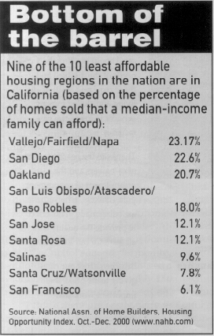

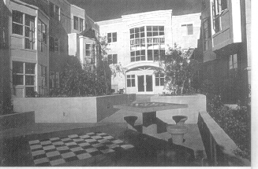

Coleridge Park Homes in San Francisco provides 49 affordable apartments for seniors. Photo courtesy of Bridge Housing.

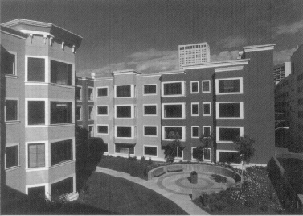

Fell Street, San Francisco, is an 82-unit affordable family rental apartment building developed by Bridge Housing in partnership with San Francisco redevelopment. Photo courtesy of Bridge Housing.

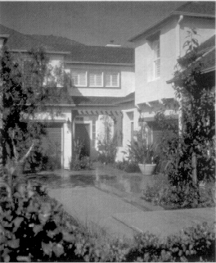
The Sycamore Grove is a small townhouse development in Orange County. Photo courtesy of the Gold Nugget Awards.
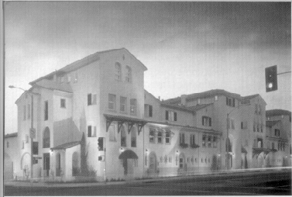

The Heritage in Pasadena, medium-density urban infill project with affordable housing. Photo courtesy of the Gold Nugget Awards and photographer Eric Figge.

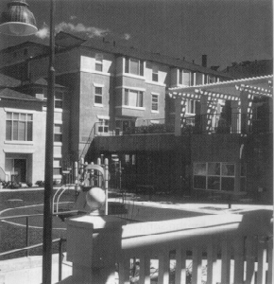

Strowbridge Court is a 96-unit transit-based affordable housing development, built in collaboration with BART in Alameda County.
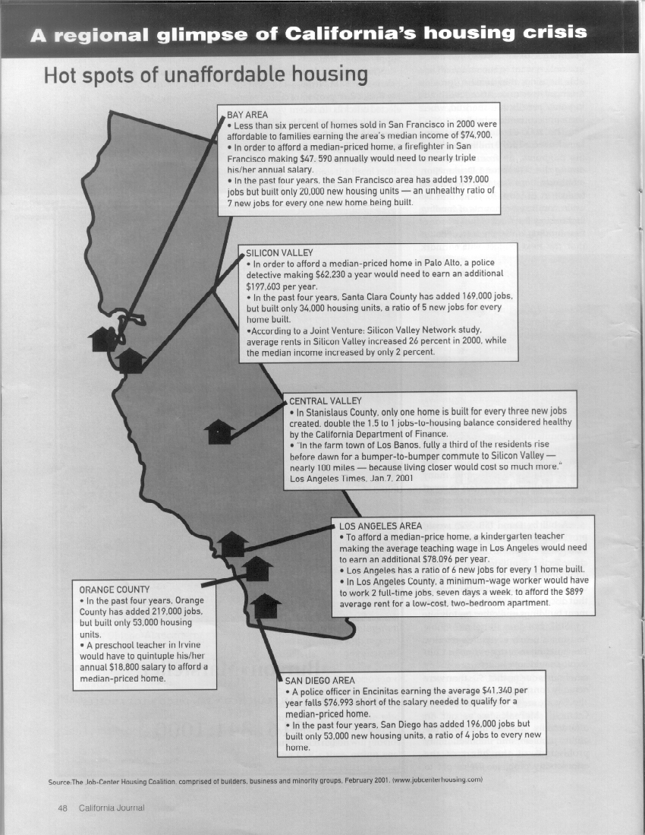

ATTACHMENT B

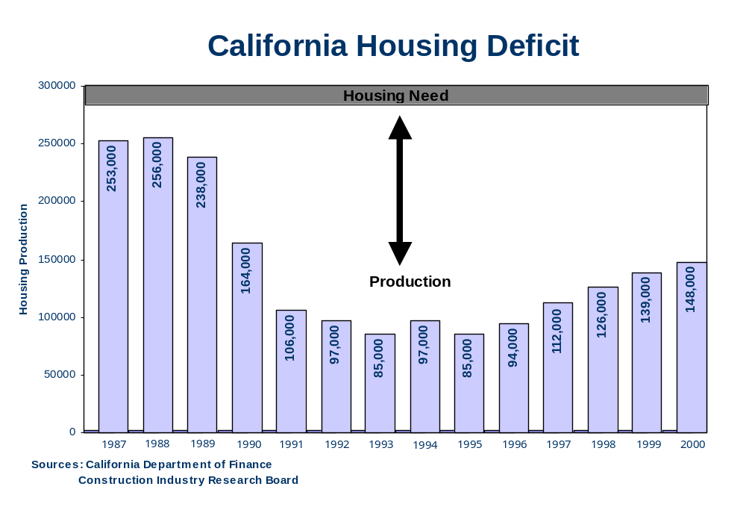

ATTACHMENT C



