The Federal Role in Housing
The federal government currently employs a range of programs, tools, and agencies in its efforts to address the nation’s housing and community development challenges. These programs are described briefly below, with more detail presented in Appendix 3 of this report. The history of government involvement in the housing sector provides useful background and context for the Millennial Housing Commission’s recommendations to Congress.

Historical Overview
The federal government first intervened in the housing market during the 1930s in an attempt to restore liquidity and stability to the financial system and to generate construction jobs. Creation of the Federal Home Loan Bank System and the Federal Housing Administration (FHA) was not intended to assist the poor, but rather to aid lending institutions and help lift the U.S. economy out of the Depression.
In 1937, the U.S. Housing Act created the public housing program, authorizing local housing authorities
to build units financed through long-term bonds to serve poor families. In 1938, the federal government chartered the first government-sponsored enterprise (GSE), which marked the beginning of a secondary mortgage market.
After World War II, the urgent housing shortage faced by returning service men and women spurred creation of Veterans Administration guarantees on mortgage loans and increased FHA activity in insuring home mortgages. The Housing Act of 1949, enacted with strong bipartisan support, established the goal of “a decent home and a suitable living environment for every American family.” The act also created the Urban Renewal (then called Urban Redevelopment) program, intended to improve communities by giving grants to localities to eliminate slums and blight by substantially reducing land acquisition costs. In addition, the act authorized funding for another 810,000 units of public housing, and took a first step toward addressing the housing needs of rural Americans by authorizing the U.S. Department of Agriculture to make loans and extend related assistance to low-income farmers.
During the 1950s, communities used Urban Renewal to fund demolition and redevelopment. The Housing Act of 1954 instituted a “workable program” requirement under which localities had to submit a plan for redevelopment—the first example of comprehensive planning being required for federal funding, a standard that continues to this day. The 1950s also saw development of a special program for nonprofit owners to provide housing for elderly or handicapped tenants, as well as continued growth in federal involvement in housing finance as the FHA became more active in insuring multifamily mortgages.
During the 1960s, the FHA introduced a wave of new housing finance programs to subsidize production
of multifamily housing for low- and moderate-income families. Below-market interest rate loans and direct subsidies of various sorts, along with new tax write-offs, were added to spur private sector participation. While limiting owners’ returns over the life of the program, the programs allowed owners to convert the properties to market rate rentals after 20 years. This program structure turned out to have perverse effects: at the end of the 20 years, the government lost the best-run and most attractive properties in good locations, and was left with the poorly located and managed properties that did not command high enough rents to cover the costs of capital preservation.
In 1965, the U.S. Department of Housing and Urban Development (HUD) was created as a cabinet-level department charged with overseeing the nation’s housing and community development programs. The 1960s also marked the launch of a new approach—the ability of public housing authorities to rent privately owned units for their tenants. This precursor to housing certificates and vouchers enabled low-income families to rent privately owned units.

By 1969, some of public housing’s poorest tenants were paying as much as three-fourths of their incomes
for rent, and payments equal to one-half of gross income were common.1 A series of amendments then eliminated PHAs’ ability to set minimum rent levels and instead capped rents at 25 percent of tenant income. Congress addressed the resulting loss in PHA operating income in 1970 by introducing subsidies intended
to cover the shortfall between rental income and operating expenses. Later, in the Omnibus Budget Reconciliation Act of 1981, Congress raised the minimum rents on public housing from 25 percent to 30 percent of income in an attempt to boost PHA income. In addition, HUD issued regulations pursuant to previously enacted legislation giving preference to families with severe housing problems.
The Housing and Community Development Act of 1974 brought about two major changes in housing programs. First, it consolidated seven categorical grant programs to localities into the Community Development Block Grant (CDBG) program, which continues to fund a broad array of community development initiatives. This program provided for local flexibility in how best to engage in community development, but required submission to HUD of a formal planning tool called the “Housing Assistance Plan.” Second, the 1974 act amended the U.S. Housing Act of 1937 to create the Section 8 program, under which the subsidy covered the difference between a fixed portion of tenant income and the “fair market rent” for the unit, as defined by HUD. The program was primarily used by, but not limited to, the private sector. Section 8 was designed to give localities the flexibility to use the funds for new construction, substantial rehabilitation, or tenant-based assistance for occupancy of existing rental units. Long-term (20- to 40-year) subsidy contracts for Section 8 new construction and moderate rehabilitation facilitated the private financing of such developments.
In the early 1980s, additional tax incentives made development of affordable rental housing even more profitable. The Tax Reform Act of 1986 then repealed accelerated depreciation and use of depreciation deductions to offset other ordinary income, precipitating a sharp drop in multifamily production. In addition, the act placed a cap for the first time on state authority to issue tax-exempt bonds for multifamily housing and imposed income limits on eligible households. At the same time, though, the act created the Low Income Housing Tax Credit (LIHTC) program, providing private-sector incentives for the development of rental housing for lower-income households. The McKinney-Vento Homeless Assistance Act of 1987 marked the first federal legislation to address homelessness by providing funding for shelters and supportive housing.
With the 1990s came introduction of the HOME Investment Partnerships (HOME) program, a block grant used by state and local governments to address affordable housing needs. Based on a series of targeting standards, data on housing needs, and activities identified in a Comprehensive Housing Affordability Strategy (later merged into what is now the Consolidated Plan, or ConPlan), recipient jurisdictions could develop their own programs and activities to meet affordable rental or homeownership housing needs. The 1990s also marked the establishment of separate allocations for elderly and handicapped persons, the introduction of funding for the revitalization of severely distressed public housing (HOPE VI), and block grants for Native American housing.

Programs Active Today
Today, the LIHTC and HOME programs support multifamily rental housing production. The federal government also promotes multifamily rental production by permitting issuance of tax-exempt bonds, through FHA mortgage insurance products, and, in rural areas, through direct and guaranteed loans provided through the Rural Housing Service (RHS)—formerly the Farmers Home Administration—of the U.S. Department of Agriculture.
Public housing is still a major source of affordable units for low-income households. The existence of large, generally high-rise, urban public housing developments—many of which are now being replaced by mixed-income developments under the HOPE VI program—has generally obscured the fact that most public housing is in smaller developments that do not share the problems generally associated with the high-rise, high-density units.
All told, the federal government subsidizes nearly 1.3 million publicly owned housing units and just over 1.9 million privately owned units. In addition, the federal housing choice voucher program provides rental subsidies to nearly 1.6 million lower-income households, enabling them to rent apartments from private landlords who are willing to accept voucher-holding tenants.
On the homeownership side, the federal government reduces costs to owners through mortgage interest and real estate tax deductions, tax-exempt bond financed mortgages for low-income first-time homebuyers, FHA and RHS mortgage insurance for low-downpayment loans with liberal underwriting, Veterans Administration loan guarantees, and RHS below-market interest rate loans to low-income rural homebuyers. The government also supports homeownership through mortgage market interventions via the GSEs—the Federal Home Loan Mortgage Corporation (Freddie Mac), the Federal National Mortgage Association (Fannie Mae), and the Federal Home Loan Bank System—all of which help to leverage and maintain a steady flow of mortgage funds to primary-market lenders.
Some of the same tools used to stimulate housing production and preservation are used to foster community development. State credit agencies (usually state housing finance agencies), which administer the LIHTC, typically award points through a competitive process to projects that support broader community development goals. Additional tools include the Community Development Block Grant (CDBG), which may be used for neighborhood redevelopment, economic development, and community services, and HOPE VI grants for the comprehensive redevelopment of public housing.
Figures 9 through 11 provide a snapshot of current federal spending on housing. In 2001, tax incentives totaling $121.2 billion made up the majority of federal housing support. The Joint Committee on Taxation estimates the FY 2001 value of the mortgage interest deduction alone at $64.5 billion, benefiting 32.1 million taxpayers.2 By comparison, direct spending on housing assistance totals $34.9 billion (Fig. 9).

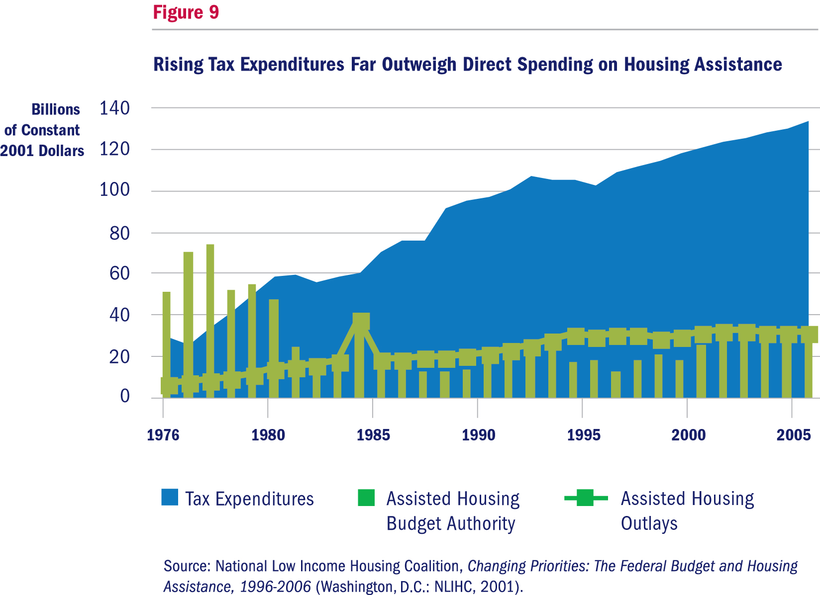

Almost all direct federal spending is targeted at renters (Fig. 10). Today, the stock of directly subsidized rental housing receives a combination of project-based and tenant-based assistance. Federal resources produce new affordable housing and pay for the maintenance of housing built under programs that have since been discontinued.

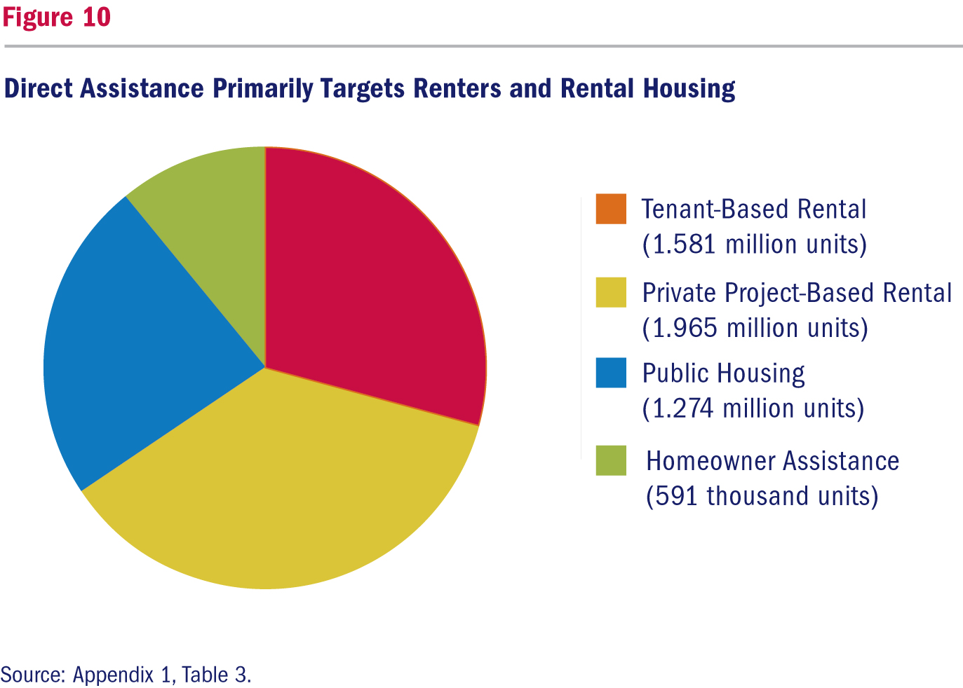

The inventory of privately owned subsidized properties consists of units produced under a variety of programs (Fig. 11). Today, however, none of these programs still produces new units except for the elderly (Section 202) and disabled (Section 811) housing programs, which provide capital grants and rental assistance for housing built by nonprofit sponsors, and the Section 515 program, which produces housing
in rural areas.

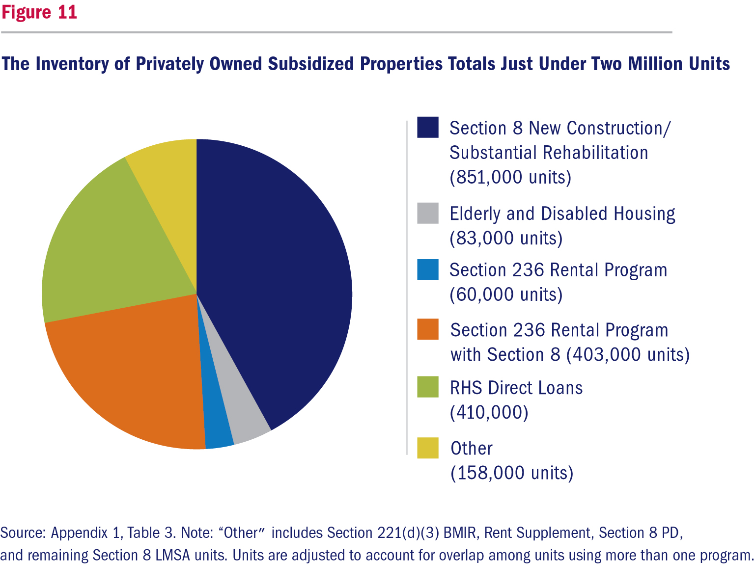

Lessons Learned
In developing new policy options, the Millennial Housing Commission looked to the lessons of history as well as to the testimony and ideas submitted during the course of its deliberations. The Commission sought to model its recommendations on measures that have worked well and to avoid the repetition of past mistakes—many of which were the unintended consequence of program implementation rather than of program design.
The lessons learned from the 70-year history of federal housing programs are many and varied. Those most influential in helping the Millennial Housing Commission craft its recommendations include:
1. Affordable housing developments cannot be isolated from the broader community in which they are located, and must provide access to decent schools, job opportunities, and transportation.
2. Decisions about the location and management of affordable housing are best made by state or local governments, rather than the federal government.
3. The private sector needs the proper incentives to be an effective partner in the federal government’s efforts to address the nation’s housing challenges.
4. When resources are limited, there are difficult tradeoffs between making rents affordable to the poorest tenants and ensuring that enough income flows into a property to cover the repairs necessary to sustain the structure’s useful life.
The Commission’s recommended new programs and suggested reforms for current programs incorporate all of these important lessons.

