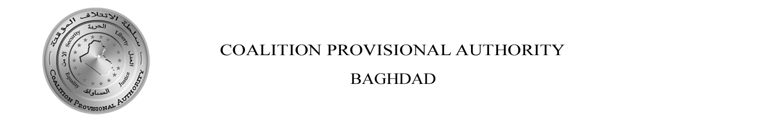
Administrator’s Weekly Report Essential Services
May 29-June 4, 2004

HIGHLIGHTS

-- The seven-day average (May 29-June 4) of peak electricity production was 4,144 MW.

-- Since May 2003, the CPA has established landline phone service for 201,618 subscribers nationwide.

-- The Ministries of Health, Education, and Higher Education welcomed new Ministers.

I. Provide Electricity Services that Meet National Needs
Improve generating capacity to 6,000 MW by June 30, 2004; Fully implement policy on allocation of electrical power; Publish draft of long term strategy; Minimize sabotage and improve security

- The seven-day average (May 29-June 4) of peak electricity production was 4,144 MW, an increase of 5 percent from the previous week. On June 2, peak production hit a high for the week at 4,251 MW.
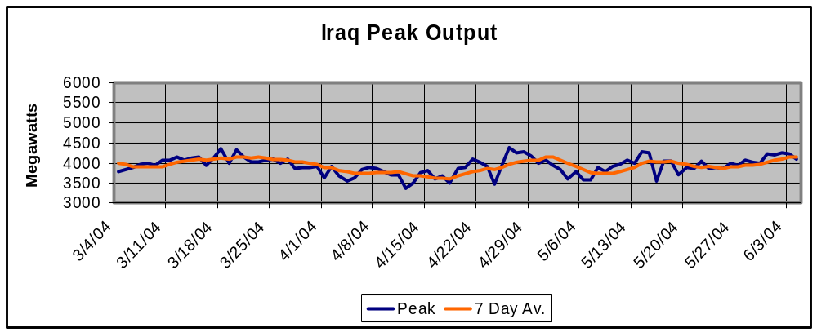
Source: Ministry of Electricity, Power Daily, June 5, 2004

- The seven-day average (May 29-June 4) of total production of electrical energy was 86,965 MWh per day, an increase of 7.7 percent from the previous week. On June 2, the total hours of electrical energy peaked for the week at 89,187 MWh.

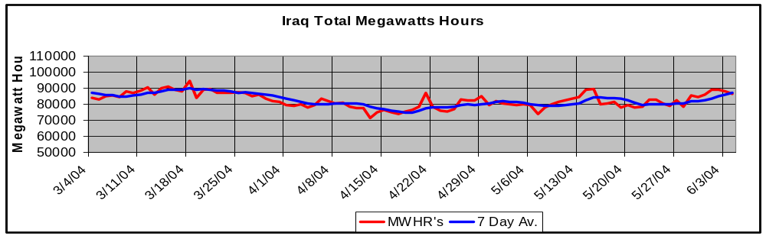
Source: Ministry of Electricity, Power Daily, June 5, 2004

- This past week, an average of 453 MW (13 generators) of generating capacity was on forced (unplanned) outage, and an average of 1,218 MW (29 generators) was on scheduled outage. Four (400 Kv) and eight (132 Kv) transmission lines are currently out of service. The Ministry of Electricity returned the Wasit Kut – Kut South 132kV line to service on June 4. The Dinis-Azadi-Qaraqosh 132kV lines 1 & 2 have been completed, and have been tested. The Ministry of Electricity and Kurdish electrical personnel are working out operational procedures, communications, and related issues. Some substation work remains to be completed at Qaraqosh. These lines are tentatively projected to be placed in service, at least between Dibis and Azadi (Erbil), soon. This will reconnect the Kurdish Regions with the Iraqi National Grid.

- The following chart represents the daily electric power consumption broken down among the North, Central (including Baghdad), and South regions. Per day during the reporting period, the North, which represents 35 percent of the total population, consumed an average of 773 MW or 20 percent of total power consumption. The Central region, which represents 25 percent of the total population, consumed 2,327 MW or 61 percent of total power. The South, which represents 40 percent of the total population, consumed 703 MW or 19 percent of total electricity consumption.

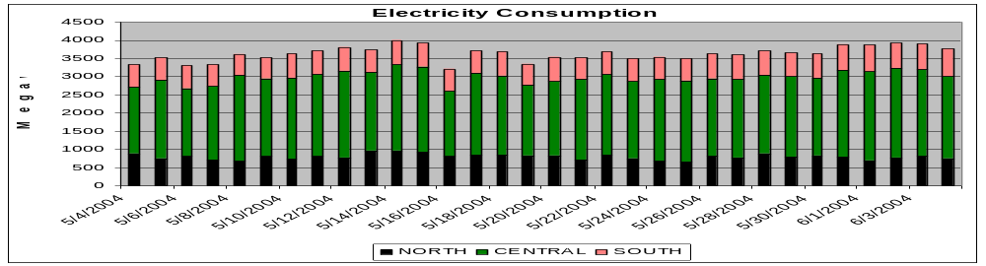
Source: Ministry of Electricity, Power Daily, June 5, 2004

Average Daily Electrical Power Distribution per Governorate as of 2004
Note: Declining hours due to increased use of air conditioners, decreased megawatt hours, and additional fighting in South Central Iraq. However, some areas showed an increase due to attempts at grabbing more power than allocated by the National Dispatch Center.
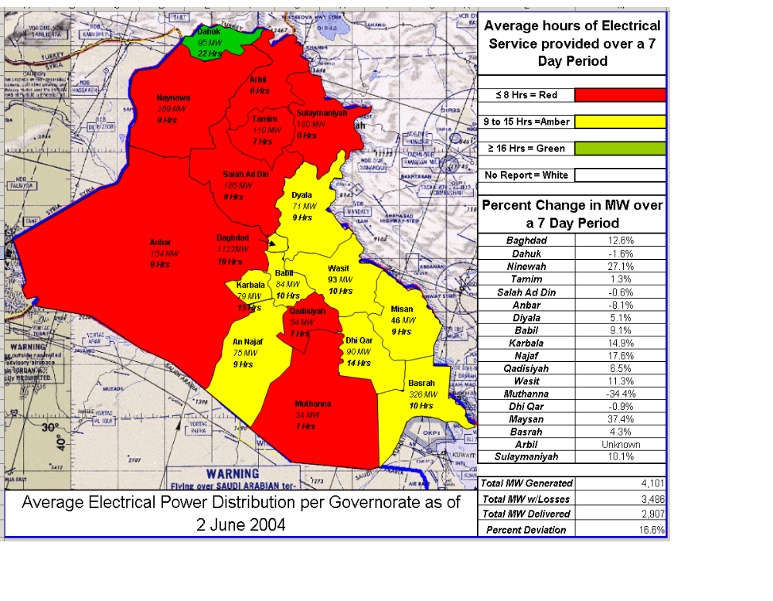Source: Ministry of Electricity

LEGEND:
GREEN Greater than 16 hours of average daily power
AMBER 8 to 16 hours of average daily power
RED Less than 8 hours of average daily power
WHITE No report

II. Reconstruct Communications and Postal Systems
Build Iraq’s First Responder Network (FRN); Establish independent regulatory agency; Upgrade Iraqi Telephone and Postal Company (ITPC) network for interoperability; Build transmission component data network for Iraq, including international gateways; Restructure ITPC and its business operations; Upgrade and modernize postal systems; Upgrade ITPC outside plant for increased subscriber capacity and use

Interim First Responder Network

- For the Baghdad Digital Network, encompassing police, fire and emergency medical technicians (EMTs), all equipment on current procurement contracts for Baghdad has been received. Work is still being completed to provide a trunked (multi-channel capacity) Ultra High Frequency (UHF) system that will improve access and minimize mutual interference and congestion.

- For the Department of Border Enforcement, radio contracts have been obligated and vehicles and radios are currently in the process of being installed and delivered. Three percent of High Frequency (HF) mobile radios and one percent of HF base radios are completely installed.

- The National Land Mobile Radio System, a public safety radio system, has contracts for 10,000 radios; however, security concerns have affected installation. Currently, Iraqi Police Services have 15 percent of handheld, 2 percent of mobile and 31 percent of base station radios completely installed. International Police Advisors currently have 80% of UHF hand held, 32 percent of HF mobile, 33 percent of HF base, 71 percent of UHF mobiles, and 17 percent of UHF repeaters radio components completely installed.

Independent Regulatory Agency

- Staff from the Office of the Senior Advisor of the Ministry of Communications participated in a training seminar for the CEO and commissioners of the new Iraqi Communications and Media Commission. This is an independent regulatory commission, similar to the U.S. FCC., which now has broad authority to regulate telecommunications and the mass media. Staff from the MOC Senior Advisor’s Office worked with the CPA Media Development team to invite experts from the U.S. and the UK to speak on a broad array of topics. CPA MOC staff members also made short presentations. The commissioners and CEO also visited the UK regulator, Ofcom, and the BBC, and held a press conference attended by Arab media. The seminar and meetings were held in London and Sussex, England.

Postal Operations

  - The MoC completed a draft copy of the five year Pro-Forma program, which is in support of the separation of the Post and Savings from the Iraqi Telephone and Post Corporation (ITPC). Of note, the plan proposes the necessary rate adjustments to balance revenue and expenses.

  - The Ministry of Communications and (MoC) and CPA officials worked to complete the proposed changes to the International Air and Hub distribution contract. The changes include a 30-day cancellation clause and payment schedule, which are more favorable to the Iraqi government.

  - The MoC is also working to mitigate the overdue arrears payment to the Universal Postal Union (UPU).

  - The MoC is working with the Program Management Office to identify equipment purchase specifications.

Telecommunications

- The following paragraphs delineate the number of landline and cell phone subscribers in Iraq, and compare them to pre-war estimates. The chart below shows the number of active landline subscribers in April 2003, the current number of active landline subscribers, the number of landline subscribers reinstated post-conflict (since May 2003), and the number of formerly active landline subscribers who remain without service (excluding the three Northern governorates).

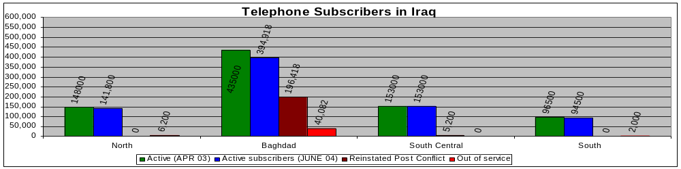
Source: CPA Senior Advisor to the Minister of Communications
Iraqi Telephone and Postal Company [ITPC]

- Since May 2003, CPA has reinstated landline telephone service for 201,618 subscribers nationwide.

- The three major cell phone companies in Iraq (Asia Cell, Iraqna, and Atheer in the North, Central, and South respectively) continue to enroll new cell phone subscribers. Cell phone subscribers total 429,342 nationwide. Currently, in Mosul, Sulaymaniyah, and Kirkuk, there are 181,241 cell phone subscribers. In Baghdad, there are 185,000 cell phone subscribers; and in Basra, Al Kut, Amarah, Samawah, and Nasiriyah there are 49,101 cell phone subscribers. Sana Tel, which operates in Sulaymaniyah, has 14,000 subscribers.

- There are now 784,218 active landline telephone subscribers in Iraq, compared to 833,000 subscribers pre-war. The total number of telephone subscribers in Iraq, including the cell phone subscribers, is 1,213,560, which is 45.7 percent greater than the number of active landline subscribers pre-war. Cell phone service was very limited pre-war.
- The penetration rate (the number of active landline telephone subscribers as a percentage of the population) is 2.89 percent vs. 3.1 percent pre-war (using an estimated population of 27,139,021 according to the Iraqi Central Statistical Organization 1997 Census, (assuming 3% annual growth)).

- The following chart shows the percentage of operational landline telephone subscribers compared to the number of active subscribers in April 2003.
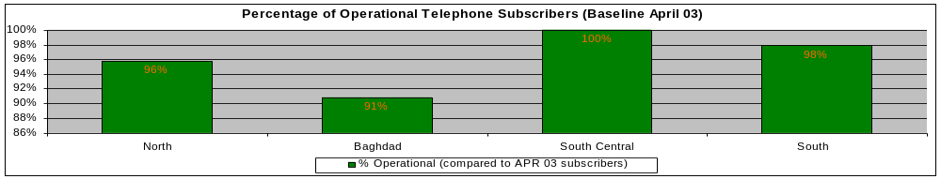
Source: CPA Senior Advisor to the Minister of Communications
Iraqi Telephone and Postal Company [ITPC]

- The following map and table show the penetration rate for cell phone users based on current data from the cell phone companies. Note: the map and table only includes areas where cell phone service currently exists.

Muthanna
10 Hrs
38 MW
Basrah
Baghdad
185,000
Mosul
Kirkuk
195,241
Sulaymaniyah
Al Kut

Samawah
49,101
Amarah
Nasiriya

Source: Ministry of Communications
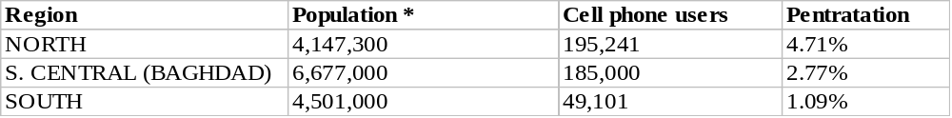
* Iraqi Central Statistical Organization 1997 Census, (assuming 3% annual growth)
- The following chart shows the number of 56k dial-up subscribers the State Owned Internet Company has signed up in Baghdad. Pre-war, there was limited service, with 3,000 Internet and 8,000 e-mail only accounts in 2002. In 2003, there were 5,000 Internet and 10,000 e-mail only subscribers. By January 1, 2004, there were 12,372 accounts, with both e-mail and Internet access. As of June 4, there are 55,000 users.

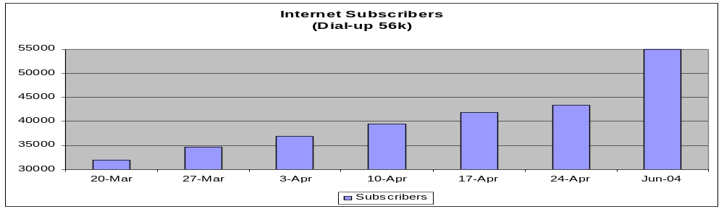
Source: Ministry of Communications

III. Improve Quality and Access to Healthcare
Develop health care organizations, management, and infrastructure; Train health care professionals; Secure system; Public health; Pharmaceuticals logistic support; Strategic communications

- Dr. Ala'din Abdul Sahib Alwan, who was serving as the Minister of Education, is now the new Minister of Health (MOH).

- The MOH has confirmed the dispersion of Primary Healthcare Centers for each governorate based on a combination of population density, population movement for religious festivals and inequities created by the previous regime. The Program Management Office (PMO) now has clear guidance on the governorate distribution and can begin detailed planning.

- A task order was issued by the PMO to a company for $51 million to renovate five maternity and children (MCH) hospitals in Baghdad, Thi-Qar, and Najaf. Meetings with the Baghdad hospitals have been completed and site visits are being planned.

IV. Improve Quality and Access to Higher Education
Oversee the basic administrative functions of higher education systems; Reform and reconstruct higher education institutions; Reintegrate the higher education institutions in the North with the rest of the country; Reintegrate Iraqi students, scholars, and scientists into the broader intellectual community; Launch a review and reform of the curriculum in all disciplines; Provide access to essential information

- A new Minister was appointed to the Ministry of Higher Education: Professor Dr. Taher Al-Bakaa, President of Mustansiriya University. He is an historian who has published books on Modern Iraq and Palestine.

- Over the past few weeks, tons of textbooks have been sent to CPA for delivery to the various Iraqi universities. Duke University alone has sent almost 200 boxes of books.

- Book warehouses have been established in Baghdad to handle the flow of book donations from the United States.

- The Fulbright Scholarship program is now on its third round and sixth information session after not being available for 14 years. Three sessions were conducted for US Military/ US Citizens serving in Iraq and three have been conducted for Iraqis to apply. The first Iraqi session yielded a turnout of 83 at the palace, the second with 79 applicants at Mustansiriyah University, and the third yielded 20 applicants.

- $8 million in US funds will be used to purchase chemistry, biology, and physics laboratories for twenty universities to be delivered in late August.

- Over $12 million should soon be available through the Program Management Office to begin the reconstruction of the joint Education-Higher Education Ministry building.

- New dormitories have been constructed for men at the former Al-Rasheed military campus and for women at Baghdad University and the dormitory previous held by the U.S. military has been returned to Mustansyriah University.

- The South Korean government reiterated it’s commitment of $5 million for Internet access and computer equipment at all 20 Iraqi universities.

- A declaration in support of academic freedom, setting the universities beyond the reach of sectarian or partisan control or coercion, was unanimously adopted by the council of university presidents and promulgated by the MoHE.

- A new College of Humanities and Democratic Studies is planned for Dohuk University and two private universities- a comprehensive American Liberal Arts in Erbil and a University for Business Administration and Economics in Sulaimania- are now taking shape.

V. Improve Quality and Access to Education
Reorganize and staff the Ministry of Education; Rehabilitate school buildings and build new schools; Advance national dialogue on curriculum reform; Continue and expand teacher training

- Dr. Sami al-Mudhaffar, who is a former President of Baghdad University and one of Iraq’s most distinguished scientists, was appointed to become the Minister of Education (MOE).

- The MOE has invited prominent educators, university professors, public officials, and representatives from NGOs to serve on a national committee on curriculum reform. The MOE expects curriculum reform, including new texts, to be completed in two years. In the meantime, the Ministry has prepared an interim curriculum on civics, history, and religious education. All address human rights, including human rights abuses by the previous regime.
- There are concerns over adequate electricity for schools this summer and contingency plans are being developed for alternative power sources.

- School security remains a concern and CPA is coordinating with Force Protection Service coverage over the summer to protect school buildings from being looted. Ministry of Education (MOE) representatives will meet with the Ministry of Interior to assess the situation and address concerns.

- National exams are successfully being conducted throughout Iraq. Joint efforts with Multinational Forces Iraq (MNFI) and MOE and Regional Operations have overcome obstacles related to security incidents. This cooperation has minimized minor disruptions in the process.

- Operation Iraqi Children, National School Supply Program is underway and even
getting congressional attention since it initially focused on hygiene items. The MOE
provided library and pre-school supply lists to the Iraqi Assistance Center to assure that
supplies meet the need of the children and are adequate for all the governorates.

VI. Improve Quality and Access to Housing
Increase financing, housing supply, and private ownership; Establish and train Ministry; Repair roads and bridges

- Omar Al-Farouk Al-Damaluchee, a former head of the Civil Engineering Department of Baghdad University, was appointed the new Minister of Housing and Construction (MoHC).

Housing

- The MoHC is working with the Credit Bank, Trade Bank, Middle East, and Central Banks of Iraq to create a home improvement loan system.

- The MoHC presented a proposal to the Program Review Board (PRB) for 504 new housing units each in Basrah, Nasiriyah, Faluja, and Karbala. This $80 million proposal has not yet been acted on by the PRB.

Roads & Bridges
- The MoHC is working with Multinational Forces Iraq (MNF-I), the Program Management Office (PMO), & USAID to coordinate reconstruction efforts in order to prioritize for construction material shortfalls.
- The MoHC presented a proposal to the Program Review Board for a new bridge at Al Hartha. This $10 million request has not yet been acted on by the PRB.

VII. Provide Opportunities for Sporting Activities and the Development of Young People
Re-establish the Ministry of Youth & Sport; Re-establish Sports Clubs, Branch Federations, Central Federations and Olympic Committee organizations; Facilitate Resumption of National and International Sporting, Youth and Community Activities; Facilitate Economic Regeneration in relation to Sporting Activities

- Ali Faiq al-Ghabhan was reinstated as Minister.

- Members of the National Olympic Committee of Iraq traveled with a representative from CPA to Jordan for meetings with the Jordanian Olympic Committee.

VIII. Restore Economically Strategic Transportation Infrastructure
Enable the Iraqi CAA (Civilian Aviation Authority) to run a civil aviation system, which will support the country's air transport needs; Enable Iraqi Port Authority (IPA) to administer a port of call with intermodal capabilities and inland container distribution; Enable Iraqi Railroad Railways (IRR) to provide domestic and international passenger and freight capabilities; Reform Civil Service at Ministry of Transportation (MoT)

- In a June 1 televised ceremony, the new Minister of Transportation (MoT), Louay Sultan Al-Erris, was introduced to the Iraqi public.

- A contract has been awarded to provide consultancy services to enable the Iraqi Port Authority (IPA) to meet the compliance requirements of the International Ship and Port Facility Security Code, which will become mandatory on July 1, 2004.

- With the words, “Alpha Sierra One Cleared to Land,” the Director General of the Iraqi General Establishment of Civil Aviation (GECA) initiated civil air traffic service for Baghdad International Airport. Additionally, CPA officials and Multinational Forces Iraq (MNF-I) signed a Memorandum of Agreement establishing GECA Air Traffic Control. This is the first civil air traffic control in Iraq since March 2003.

- The MoT secured approximately $6 million in USAID funds, which can be used for used for airport equipment and training. The aviation team is developing a prioritized list for fund use.

▪ MoT representatives facilitated a tour of 447th Air Expeditionary Group (AEG) Meteorological Unit for Iraqi Meteorological Organization (IMO) engineers. This is an integral part of transition to civilian meteorological services as the military draws down through the summer.

▪ Two MoT State Owned Enterprises (State Company for Land Transportation Company and Al-Dhilal) and two MoT joint-venture companies (Al-Badya and The Iraqi Company for Land Transportation) have signed a tariff agreement with the Ministry of Trade to augment Trade’s grain hauling effort from the Port of Umm Qasr.

IX. Provide Food Security for all Iraqis
Enhance capacity of Ministry of Agriculture; Assure supply of inputs; Strengthen research system; Ensure adequate stocks for Public Distribution System (PDS); Monitor food security; Hand over administration of system in the North; Initiate reform of rations basket; Environmental initiatives

- The Iraqi Interim Government named Mohammed al-Jibouri the new Minister of Trade (MOT). CPA/Trade will brief him on the issues and status of the public distribution system over the coming week. CPA and the MOT need to reach agreement on activities that will require close IRMO/MOT consultation after the handover. This should include the ongoing initiatives in procurement, logistics, and connectivity.

- Steady progress is being made in acquiring the trucks required for transporting PDS commodities. Off-load capacity of wheat has improved and the number of security incidents on the roads leading from the Port of Umm Qasr (UQ) has declined. MOT reports, confirmed by a CPA official in Umm Qasr, indicate that an average of 200 trucks per day have been transporting wheat and rice from UQ for the past week.

- MOT continues to negotiate specifications for the purchase of wheat from Syria. To date MOT officials have not been able to come to agreement with Syrian officials on specifications to ensure that all wheat purchased is fit for human consumption.

- The Australian Wheat Board, through its agent company Alia, is negotiating with the Iraqi Railroad Co. for possible shipment of wheat from UQ by rail.

- Due to competing demands on the Iraqi Trade Bank, not as many Letters of Credit (L/C) have been issued as anticipated to complete the first phase of MOT commodity procurement. CPA will identify a way to get the ITB to prioritize food contract L/Cs. Further delays in completing the L/Cs (to date, 30 of 231 have been issued) will affect the pace at which buffer stocks are formed.

- A schedule for the second phase of MOT procurement will be finalized this week, with the first tenders to be released within the next two to three weeks.

- Training of the MOT Logistics Unit personnel in Rome is proceeding on schedule, with individual work plans being developed for the eleven participants. MOT/Baghdad is coordinating with MOT/Logistics Unit/Rome to correct some of the information in the weekly pipeline report.

- The first activity of the “Connectivity Initiative” will be to train MOT technicians in Dubai in the installation of equipment in MOT/ Baghdad headquarters. Training will start within two weeks, followed by two to three weeks training in Jordan of field installation staff.

- The Oil for Food Coordination Center is beginning to draw down and will transfer responsibility for most activities to Iraqi ministries as of mid June. Iraqi Central Bank authentication officials should be able to move by the end of June from the Coordination Center to a new facility the bank is renting.

- Planning is underway with the MNF-I to further improve security on main food supply routes and develop contingencies in the event that security worsens.

- The following chart shows the current PDS stocks and scheduled commodity arrivals as a percentage of total requirements from the end of May until transition on July 1. The CPA goal is to provide sufficient ration stocks for July, plus a three-month buffer. On the graph below, 100 percent of opening stocks in each commodity category indicates that this goal has been achieved. CPA has procured substantial additional shipments of most food basket commodities which are not shown, as these shipments will arrive after July 1.

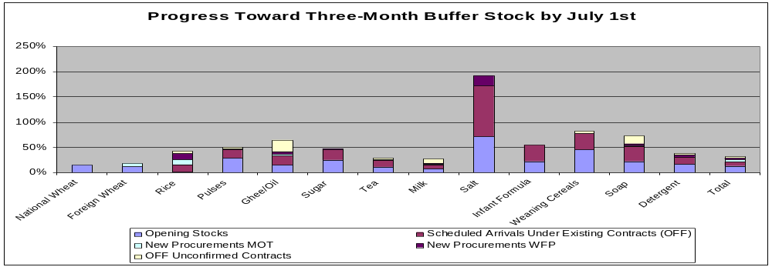
Source: CPA Food Security Team

- Note: Oil for Food (OFF) unconfirmed contracts are those contracts for which a valid letter of credit exists but no shipping documentation has yet been received by the Oil for Food Coordination Center. As OFF contracts are fulfilled they are replaced by the Ministry of Trade (MOT) and World Food Program (WFP) procurement.

- This chart represents the information above but in days of supply, based on the goal of a three-month buffer stock by July 1. The line represents the current goal status of 114 days (end of May to transition, plus 90 days).

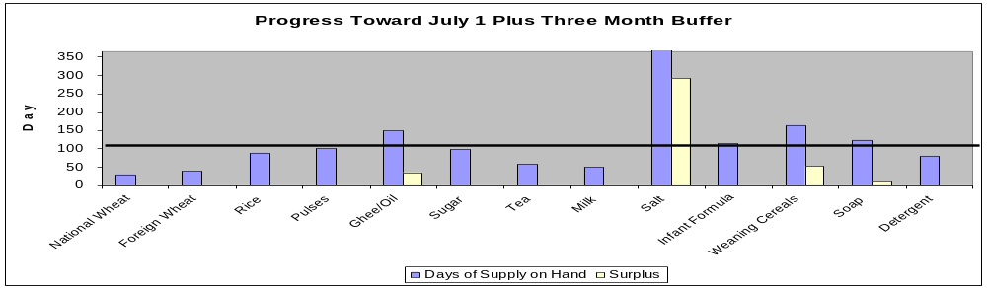
Source: CPA Food Security Team

